


USB 2.0 Network Storage Server
The TS-U100 Network File Server is a quick and easy economical solution that adds storage to your existing network. It includes a Web based utility that manages storage access through IP filtering and supports network time protocol (NTP) to keep track of data access. With a FTP Server service and hot-swappable features, the TS-U100 simplifies installation to meet large data demands.

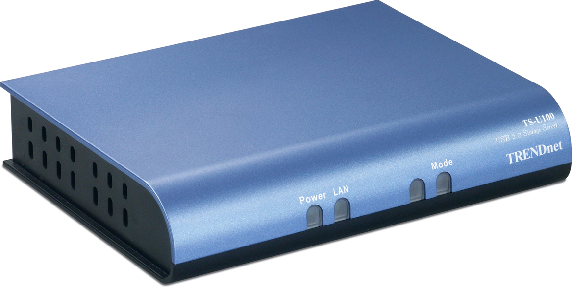

TS-U100

Features
- Compliant with USB 1.1 and USB 2.0
- Built-in-one 10/100Mbps auto-MDIX fast Ethernet LAN Port and 2 USB 2.0 ports
- Provides Open mode and Account Mode
- Acts as DHCP client to locate IP from DHCP server or Auto-IP
- Provides FTP Server for remote access
- Automatic download or back up scheduling support
- Require to use with a USB 2.0 external disk drive, flash disk, or CD-ROM storage devices
- Provides windows or web based configuration
- Security with IP address filtering to ALLOW or DENY access
- Automatically self tests the circuits of Flash Memory, DRAM, Ethernet Port, and USB 2.0 Ports when power is on
- User account management
- Supports Windows 98/98(SE)/ME/NT/2000/XP and Linux SMB Operation System
- Web based administrative program stored into flash ROM of the server
- Supports UPnP for Windows XP
- Supports Network Time Protocol (NTP) to track data access
- 2-Year Warranty
Specifications
Hardware
Standard | IEEE 802.3, IEEE 802.3u, USB 1.1 and USB 2.0
Port Interface | 1 x 10/100 RJ45 Connector (Auto-MDIX)  2 x USB 2.0 Ports  1 x Power Port
LEDs | Power, LAN, Mode
Buttons | Reset, Unmount
Power Consumption | 5VDC, 2.5A External Power Adapter
Dimensions (L x W x H) | 147 x 112 x 30 mm (5.79 x 4.41 x 1.18 in)
Weight | 196g (6.9 oz)
Temperature | Operation: 5°C ~ 50°C (41°F ~ 122°F) ; Storage: -20°C ~ 50°C (-4°F ~ 122°F)
Humidity | Operation: 10% - 90%; Storage: 5% - 95% (Non-Condensing)
Certification | CE, FCC
Firmware Specification
Standard | IEEE802.e, IEEE802.3u, USB2.0, USB1.1
DHCP Client | Assigns IP address from DHCP server, Auto-IP
File System Type | Fat16 / Fat32
Security | IP Filtering; User Account Management

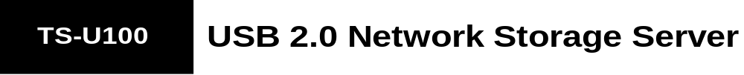

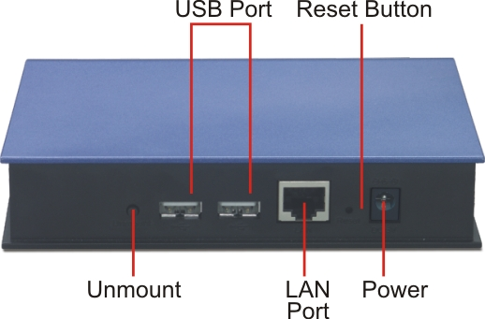
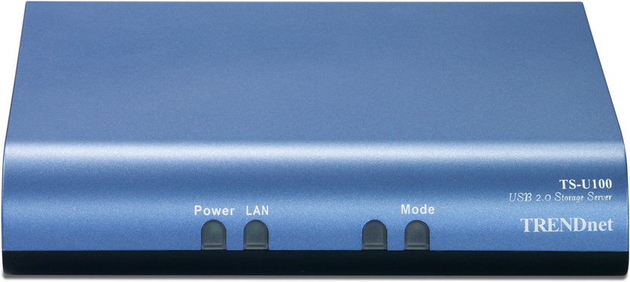

Front View
Back View

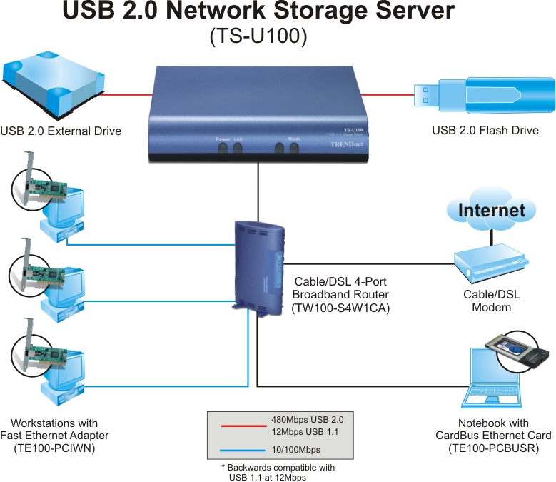

Network Storage Solution with TS-U100

Package Contents Related Product
- TS-U100 - TS-U200
- Quick Installation Guide
- CD-ROM (UG & Utility)
- Power Adapter (5V DC, 2.5 A)
To order please call: 888-326-6061 • Sales: sales@trendnet.com
Support: support@trendnet.com • Tech Support Hotline: 1(310) 626-6252
Official Site: www.trendnet.com

