
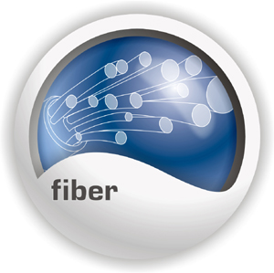
10/100Mbps TX to 100Base-FX
Multi-Mode Fiber Converter

TRENDnet’s TFC-110MSCE or TFC-110MSTE Fiber Media Converter transforms 10/100Base-TX UTP/STP media to 100Base-FX media and vice versa. The 10/100Base-TX Port Auto-Negotiating 10 or 100Mbps connection speed with Auto-MDIX media type. The fiber connection can be multi-mode SC or ST type. This converter will give your Switch/Hub the ability to interface with fiber connection over a distance up to 2 km.

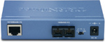
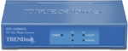

TFC-110MSCE

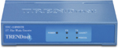
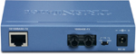

TFC-110MSTE

Features
- Compliant with IEEE 802.3 10Base-T and IEEE 802.3u 100Base-TX, 100Base-FX Standards
- Provides One Port 10/100Base-TX Auto Negotiation with RJ-45 Connector
- Provides One Port 100Base-FX Multi-Mode Fiber Optic with SC (TFC-110MSCE) or ST (TFC-110MSTE) Connector
- Auto MDI-X for 10/100Mbps-TX Port
- Auto-Negotiation for Speed and Duplex Mode on 10/100Mbps-TX Port
- Provides a slide Switch for Full and Half Duplex Selections on FX Port
- Hot Pluggable & Wall-Mountable
- 5-Year Warranty

Specifications (MMF: Multi-Mode Fiber)
Model Name | Wavelength | Media | Pout | Sensitivity | Power
TFC-110MSCE | 1310nm | MMF | -19dBm | -32dB | -21dB
TFC-110MSTE | 1310nm | MMF | -19dBm | -32dB | -21dB

Hardware
Standard | IEEE 802.3 10Base-T  IEEE 802.3u 100Base-TX, 100Base-FX
Network Media | 10Base-T: UTP Cat. 3, 4, 5, EIA/TIA-568 100-ohm STP  100Base-TX: UTP Cat. 5, EIA/TIA-568 100-ohm STP  100Base-FX: 50/125 um or 62.5/125 um Multi-Mode Fiber Optic Cable, Up to 2km
Protocol | CSMA/CD
Ports | 1 x 10/100Base-TX  1 x 100Base-FX
Transfer Rate | 10Base-T : 10Mbps/20Mbps (Half/Full Duplex)  100Base-TX : 100Mbps/200Mbps (Half/Full Duplex)
Diagnostic LED | Per Unit : Power  Per Port : Link/Activity, Full-Duplex/Collision
Power Adapter | 7.5V DC, 1A External Power Adapter
Power Consumption | 2 watts (max)
Dimensions | 116 x 70 x 25mm (4.6 x 2.75 x 0.98 inches)
Weight | 200g (7 oz)
Temperature | Operating : 0° ~ 40° C (32° ~ 104° F)  Storage : -25° ~ 70° C (-13° ~ 158° F)
Humidity | 5% ~ 90% RH
Certification | FCC,CE

To order please call: 888-326-6061
3135 Kashiwa Street • Torrance, CA 90505 • (310) 891-1100 • Fax: (310) 891-1111

Sales: sales@trendware.com • Support: techsupport@trendware.com
Official Site: www.TRENDnet.com

