

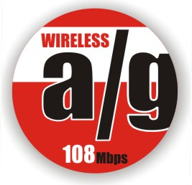
108Mbps 802.11a+g Wireless Access Point

The TRENDnet TEW-510APB Dual Band Super A+G Access Point meets the growing demand for bandwidth intensive applications such as streaming media. The TEW-510APB provides seamless integration to compatible 802.11a/b/g wireless clients for high-speed Internet access. The TEW-510APB secures wireless communication with WEP, WPA or MAC filtering and provides fast frames, frame bursting, frame compression, and dynamic turbo for Super A or Super G clients.
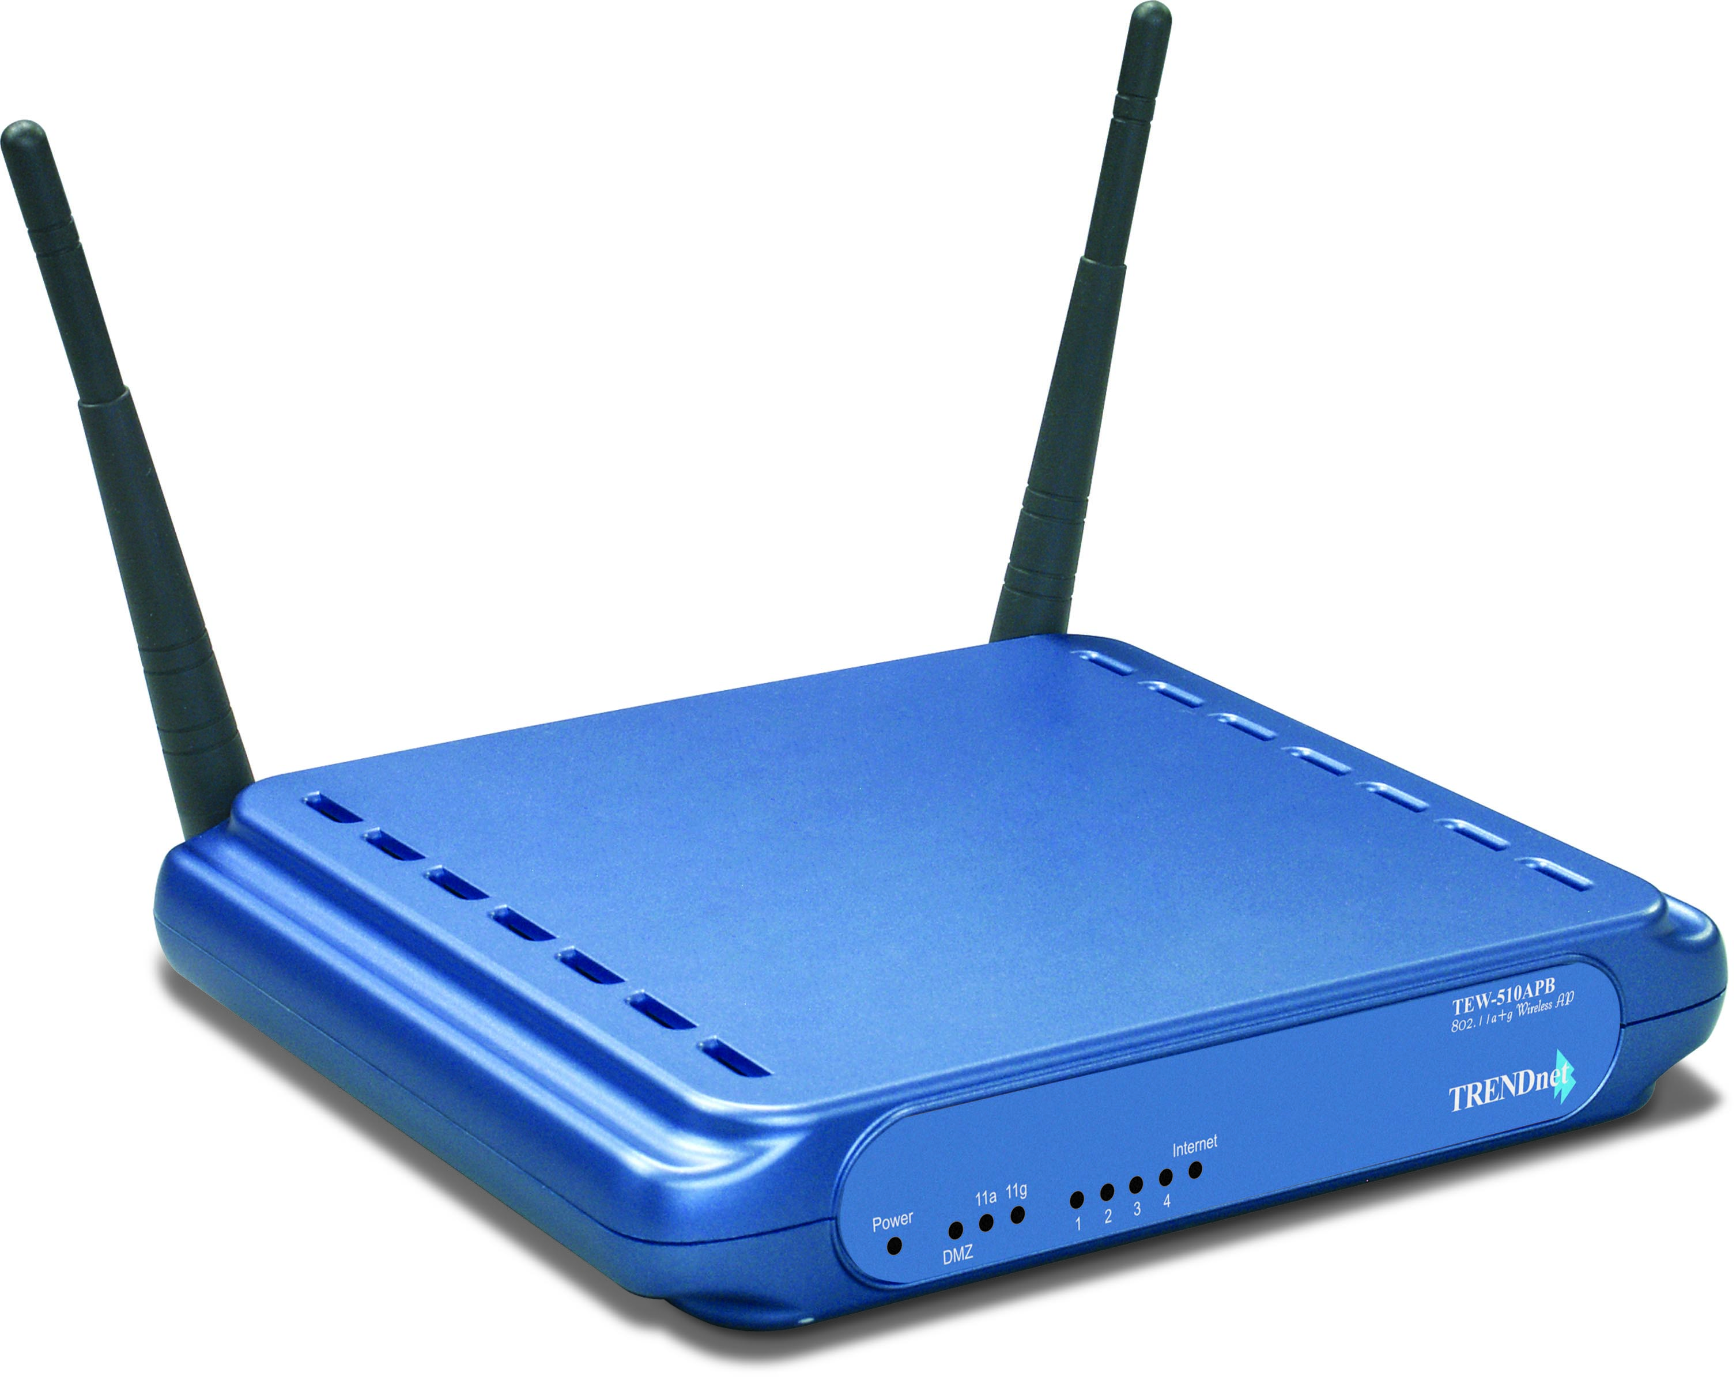

TEW-510APB

Features
- Wi-Fi Compliant with IEEE 802.11a, 802.11g and IEEE 802.11b Standards
- Uses 5 GHz or 2.4 GHz Dual Band Design, which Complies with Worldwide Requirements
- Supports WDS Access Point, AP Client/Repeater Modes
- Supports Super AG and XR (eXtended Range) technology Data Rate up to 108Mbps (AP Mode Only)
- Dynamic Data Rate Scaling at 54, 48, 36, 24, 18, 12, 9 and 6Mbps for 802.11a/g
- Dynamic Data Rate Scaling at 11, 5.5, 2 and 1Mbps for 802.11b
- Supports ESSID Enable/Disable Feature to Increase Security
- Supports 64/128/152-bit Wired Equivalent Privacy (WEP)
- Supports WPA and WPA-PSK
- Easy Configuration with Web Browser and Flash Memory for Firmware Upgrade
- Compliant with Windows 95/98/NT/2000/XP/2003 Server, Linux and Mac OS
- Range of 30 ~ 100 meters Indoor (depends on the environment)
- Range of 50 ~ 300 meters Outdoor (depends on the environment)
- 3-Year Warranty
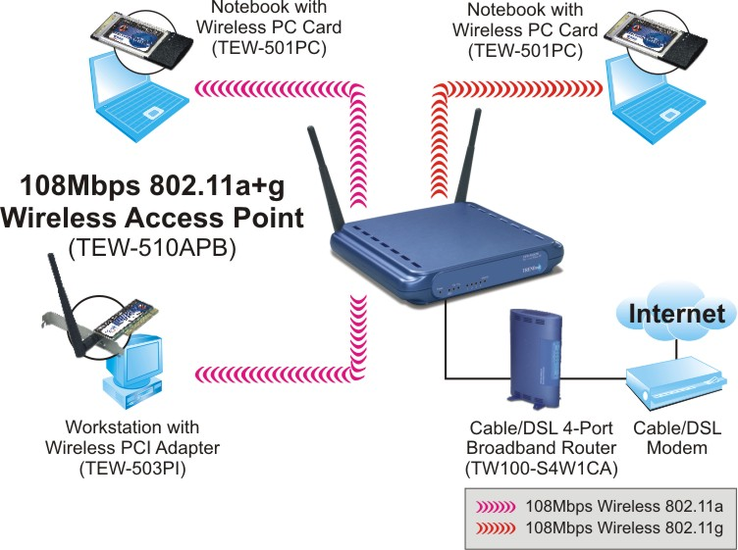
802.11a/g Wireless Networking Solution
* Due to European Wireless Regulations, Super A mode is not supported in the EU version.

Specifications
Hardware
Standards | Wired: IEEE 802.3 (10Base-T), IEEE 802.3u (100Base-TX)  Wireless: IEEE 802.11a (54Mbps), 802.11b (11Mbps), IEEE 802.11g (54Mbps)
Interface | LAN : 1 x 10/100Mbps Auto-MDIX Port  Reset button : Reset settings to factory default
LED Indicators | Power, Link/Act, Full/Col, 11a Link/Act, 11g Link/Act
Network Protocols | TCP/IP, NetBEUI, IPX/SPX
Power Source | 5V DC, 2.5A External Power Adapter
Dimensions (LxWxH) | 198 x 160 x 33 mm (7.8 x 6.3 x 1.2inches)
Weight | 0.7kg (1.54 lbs)
Temperature | Operating: 0°~ 40°C (32°F~ 104°F)  Storage: -20°~ 60°C (-4°F~ 120°F)
Humidity | Max. 90% (Non-Condensing)
Certification | FCC, CE
Wireless
Module Technique | 802.11b: CCK (11 and 5.5Mbps), DQPSK (2Mbps), DBPSK (1Mbps)  802.11a/g: OFDM with BPSK, QPSK and 16/64-QAM Sub-Carrier Modulations
Frequency Range | 802.11a: UNI-Band 5.15 ~ 5.85 GHz (Subject to Local Regulations)  802.11b/g: ISM-Band 2.412 ~ 2.497 GHz
Antenna | 802.11a: 4dBi (Peak Gain); 802.11b/g: 2dBi (Peak Gain)  2 x Dual Band Diversity Detachable Antenna (Female Reverse SMA Connector)
Data Rate (auto fallback) | 802.11b: 11Mbps, 5.5Mbps, 2Mbps, and 1Mbps  802.11g: 54Mbps, 48Mbps, 36Mbps, 24Mbps, 18Mbps, 12Mbps, 9Mbps and 6Mbps  Super AG: 108Mbps
Security | 64/128/152-bit WEP & WPA  MAC Address Filter
Transmit Power | 802.11a: 16dBm (max) @ 16QAM R3/4  802.11b: 18dBm (typical)  802.11g: 16dBm (typical)
Receiving Sensitivity  (802.11a/b/g) | 108Mbps 10 ^{– 5} BER @ -69 dBm (Turbo Mode)  802.11a: 54Mbps 10 ^{– 5} BER @ -67 dBm  802.11b: 11Mbps 10 ^{– 5} BER @ -80 dBm  802.11g: 54Mbps 10 ^{– 5} BER @ -65 dBm
Channels | 802.11a: Subject to Local Regulations  802.11b/g: 1~ 11 (US), 1~13 (EU)
Package Contents Related Products
- TEW-510APB - TEW-501PC
- Multi-Language QIG - TEW-503PI
- CD-ROM (User’s Guide) - TEW-504UB
- Power Adapter (5V DC, 2.5A) - TEW-511BRP
- RJ-45 Cable (1.5m)

To order please call: 888-326-6061
3135 Kashiwa Street • Torrance, CA 90505 • (310) 891-1100 • Fax: (310) 891-1111

Sales: sales@trendware.com • Support: techsupport@trendware.com
Tech Support Hot Line: 1-310-626-6252

Official Site: www.TRENDNET.com

