Model: 15-AH28B (H/W: A1)

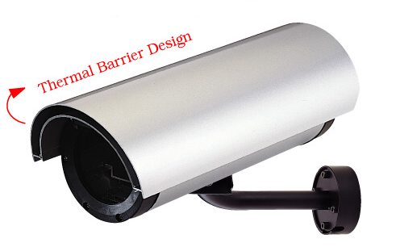
Camera Housing
15-AH25B

Features

- Additional heat insulation
- Aluminum construction
- External use
- Flip open top
- Require additional equipments for cable installation
- 1 Year Warranty

Specification

ITEMS |  | 15-AH28B (H/W: A1)
Housing Size | L mm  W mm  H mm | 440 (17”)
Housing Size | L mm  W mm  H mm | 139 (5.5”)
Housing Size | L mm  W mm  H mm | 119 (4.7”)
Max Camera Size | L mm  W mm  H mm | 195 (7.7”)
Max Camera Size | L mm  W mm  H mm | 70 (2.75”)
Max Camera Size | L mm  W mm  H mm | 70 (2.75”)
Weight |  | 2kg (4.55lb)
Clear Window Area |  | Ψ78
Glass |  | 3mm
Housing Material |  | Aluminum
Finish |  | Light Gray Powder – coating Body, Black End Caps
Proposal |  | Outdoor
Heater |  | Turn on at 5℃±2℃, Turn off at 10℃±2℃
Fan |  | Turn on When Power in
Power Supply |  | 90 ~ 230V AC

Camera Housing
15-AH25B

Supported Models

- TV-IP100 / TV-IP100W
- TV-IP201 / TV-IP201W
- TV-IP301 / TV-IP301W

Ps. Cameras need to use the Camera’s own power adapter

Heavy Duty Bracket
- Cable for camera can be run through centre of bracket for anti tamper protection
- Max Load: 10 kg.
- Construction: Steel
- Fixing: 4 screws
- Height: 230 mm
- Swivel Angle: 90ﾟ
- Tilt Angle: 120ﾟ
- Weight: 4.7kg (10.5lb)
- Dimension: 6.7 x 3 x 48 cm (2.6 x 1.2 x 19 inches)

