
VoIP USB Phone Adapter

The ClearLink™ VoIP USB Phone Adapter allows you to make and receive phone calls through Skype using a regular telephone. A simple hot key allows you to switch easily between a Skype and a regular phone call. This USB adapter is an affordable solution for making VoIP phone calls through your existing phone.



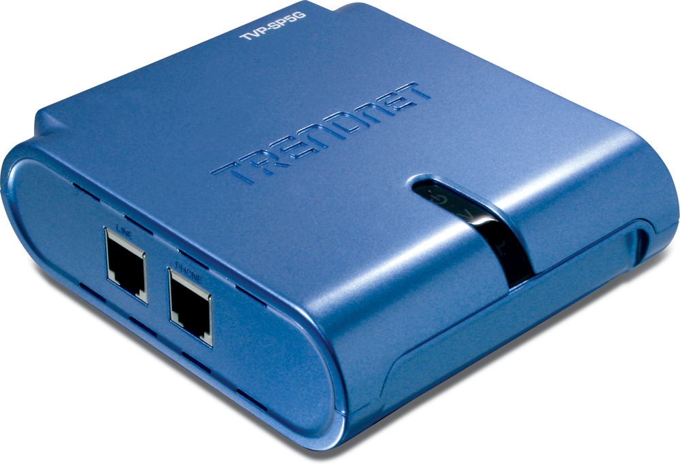

TVP-SP5G (v1.0R)
Features
- Receive / Make regular or Skype calls with your existing telephone
- Remote Calling feature support
- USB Bus-powered, no external power source needed
- Compliant with Windows 2000/XP
- Easy installation with Windows Based Utility and Plug & Play
- 2-Year Warranty
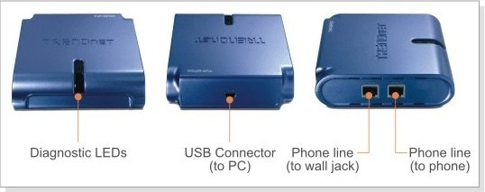
Specifications
Hardware
Standard | USB 1.1
Interface | 2 x RJ-11 port  1 x USB mini-B port
Power | Bus-Power (USB)
LED | Power, VoIP, Telephone
LCD | Resolution: 128 x 64 pixels  Size: 32 x 19.7mm  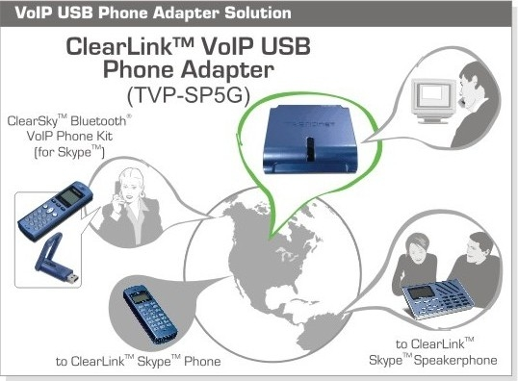  Backlight: enabled  Multiple Language Display: enabled
Dimension | 90 x 105 x 30mm  (3.5 x 4.1 x 1.2 inches)
Operating  Temperature | Operating: 0° ~ 40° C (32° ~ 104° F)  Storage: -10° ~ 70° C (° ~ ° F)
Humidity | 10% ~ 90% (Non-Condensing)
Certifications | FCC, CE

Package Contents Related Products
- TVP-SP5G - TVP-SP1BK
- Multi-Language Quick Installation Guide - TVP-SP2
- USB Cable - TVP-SP3
- Utility CD-ROM

To order please call: 1-888-326-6061 (USA)

Sales: sales@trendnet.com • Support: techsupport@trendnet.com
www.TRENDnet.com

