


ClearSky ™ Bluetooth VoIP Conference Phone Kit

The ClearSky™ VoIP Bluetooth Conference Phone Kit allows you to hold quality conference calls through a Bluetooth connection. Advanced echo cancellation technology and superior noise suppression design provides a business quality conferencing experience. This Bluetooth Class I device can easily hold conference calls wirelessly up to 100 meters away.

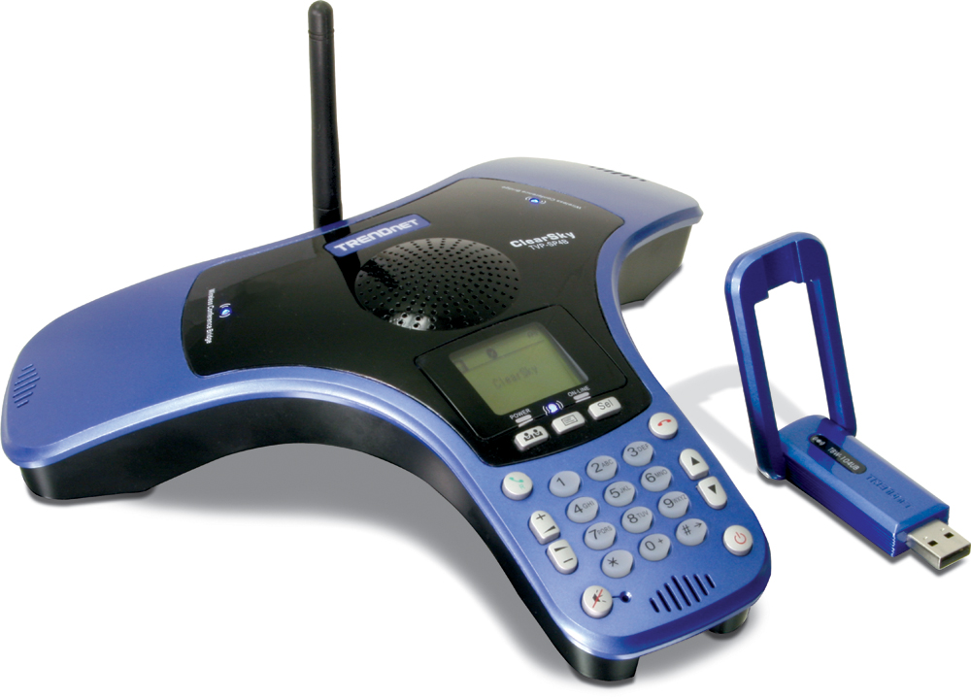

TVP-SP4BK (v1.0R)

Features
- Compliant with Bluetooth v2.0 Specification with EDR (Enhanced Data Rate) support
- Backward compatible with Bluetooth v1.1 and v1.2 devices
- Compliant with Class I Bluetooth Operations
- Advanced acoustic echo cancellation technology and Superior noise suppression
- Support Full-Speed Bluetooth operation with Full Piconet support
- Support Graphical LCD display with status Indicators
- Headset support for voice communication such as Skype, MSN Messenger, and Yahoo Messenger
- Full Skype support allows users to use Skype features directly from the phone (such as SkypeIn™ calls, SkypeOut™, Status change, Conference Call and etc.)
- Compatible with Windows 2000/XP Operating Systems
- Multi-Language LCD User Interface Support (English, French, German, Spanish & Italian)
- ClearSky Long Range Support up to 100 meters (328 ft.) (depends on the environment)
- 2-Year Warranty
Specifications
Hardware
Standards | Class I Bluetooth v2.0 with EDR  Backward Compatible with Bluetooth v1.1, v1.2
Interface | Mini-B USB Connector for charging  3 built-in mono microphone  1 built-in mono speaker
Adapter Interface | USB 1.1, 2.0 / External Dipole Antenna
Display | 128 x 80 pixel (STN LCD with back light)
LED Indicator | Power, MIC enable, Mute, Online
Battery | 3.7V 650mAh Lithium-ion Rechargeable Battery (built-in)
Cable | Type A to Mini-B USB Cable (1m / 3ft.) for charging
Power Consumption | Normal Mode: 30 days. Stand by Mode : 72+ hours, Talk Time : 4+ hours
Dimensions | Bridge: 242 x 242 x 54 mm (9.5 x 9.5 x 2.1 in.)  Adapter: 71.25 x 35.6 x 11.25 mm (2.8 x 1.4 x 0.44 in.)
Unit Weight | Bridge: 0.5kg (1.1lb) / Adapter: 10 g (0.35 oz.)
Temperature | Operation: 0°~ 50°C (32°F~122°F); Storage: -20°~ 70°C (-4°F~158°F)
Humidity | 10~90%
Certifications | CE, FCC
Phone Features
Volume | Volume up: Vol +; Volume down: Vol -; Mute
Skype Support | - Sync Contact list, History, SkypeIn, SkyOut  - Conference Call, Skype Credit Status  - Support Status Change (Online, Offline, Skype Me, Away, Not Available, Do not Disturb and Invisible)
Bluetooth
Frequency | 2.4 ~ 2.4835 GHz ISM Band
Spread Spectrum | Frequency Hopping and Adaptive Frequency Hopping
RF Output Power | 17dBm (typical)
Receiving Sensitivity | -90dBm@0.1%BER ( typical )
Date Range | Up to 100m (328 ft.) depends on environment

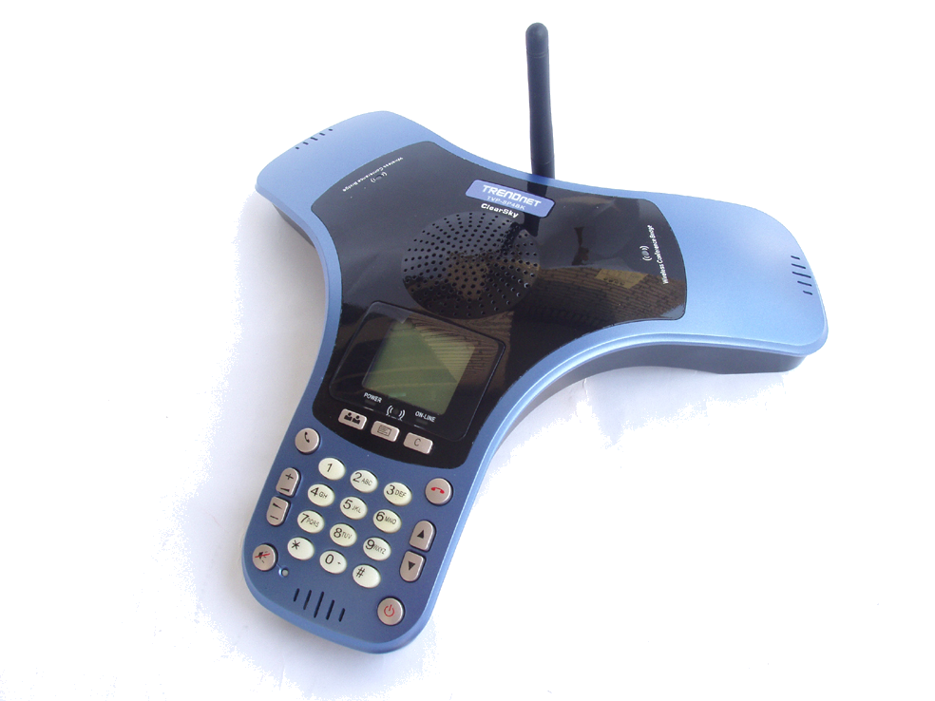
miniUSB Connector
MIC 2
MIC 3
MIC1
Antenna
Speakerphone
Mute LED
MIC2 LED
MIC3 LED
MIC1 LED
Bluetooth LED
Power LED
LCD:128 x 80
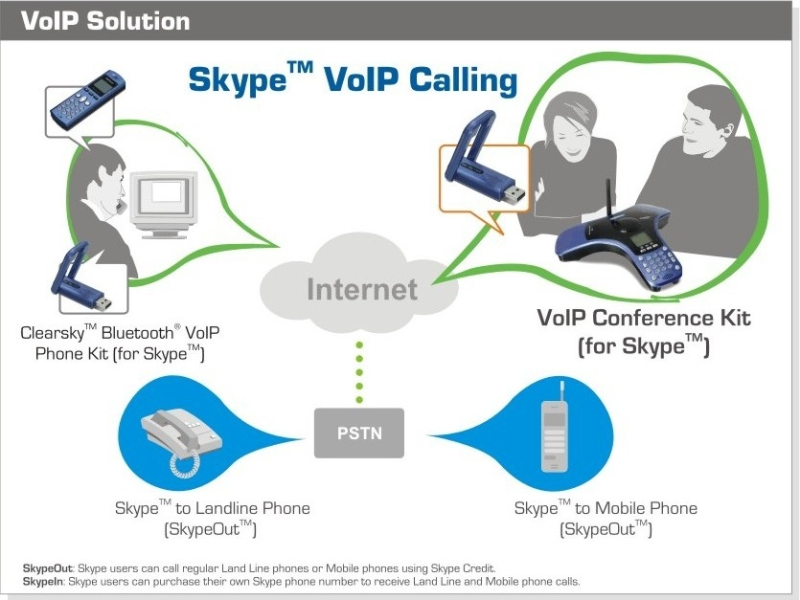

Package Contents Related Products
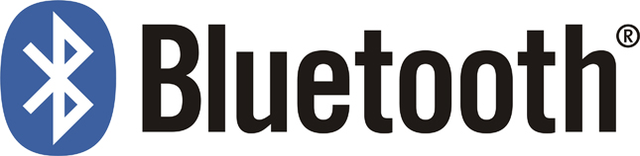
- TVP-SP4B - TVP-SP1BK
- TBW-104UB - TVP-SP2
- Multi-Language Quick Installation Guide - TVP-SP3
- CD-ROM (Driver/User’s Guide)
- USB Cable (1m/3 ft.)

To order please call: 866-845-3673 • Sales: sales@trendnet.com
Support: support@trendnet.com • Tech Support Hotline: 1(310) 626-6252
Official Site: www.TRENDnet.com

