


Wireless Internet Camera Server
TRENDnet's TV-IP100W Wireless Internet Camera Server is the perfect device for remote monitoring and transmitting real-time events over the Internet. With the flexibility of IEEE 802.11b and 10/100Mbps LAN connectivity, the TV-IP100W functions as a video/surveillance camera allowing you to view live events with your web browser via Internet or Intranet. This Internet Camera Server has VGA quality streaming video, automatic image capture, and event notification via e-mail, making it the ideal solution for Internet video broadcasting applications.
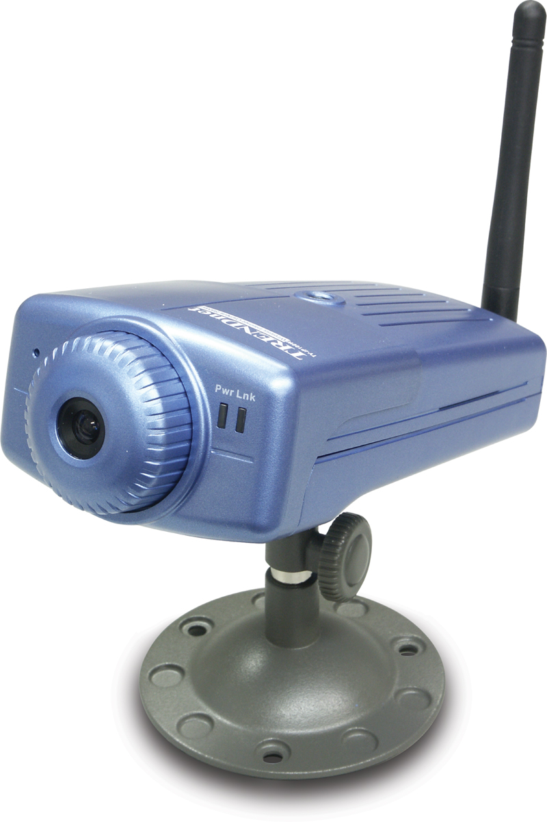

TV-IP100W

FEATURES
- Supports both ActiveX control for Internet Explorer and Java applet for Internet Explorer and Netscape Navigator
- Allows for remote access from web browser for live image viewing
- Supports TCP/IP networking, SMTP e-mail, HTTP and other Internet related protocols
- Supports in a mixed operating system environment such as Windows and Macintosh
- Supports web configuration with password protection
- Supports both 10/100Mbps Ethernet/Fast Ethernet and IEEE 802.11b 11Mbps wireless networks
- Powerful Windows IPViewSE Application Software for multiple cameras monitoring, image capturing, and video recording (Windows 98/ME/2000/XP)
- E-mail notification with captured images
- Broad range of applications for monitoring homes, offices, banks, hospitals, and a variety of private and public monitoring
- 3-Year Warranty
TREND SPEC’S

Wireless Specification
Wireless Standard: | IEEE 802.11b
Data Rate: | 1, 2, 5.5, 11 (Mbps)
Module Technique: | DSSS (Direct Sequence Spread Spectrum)
Antenna: | 2 dbi Female Reverse SMA connector
Frequency: | 2.4 ~ 2.4835Ghz (ISMB)

Wireless Specification (continued)
Output Power: | 17 dBm (typical)
Receiving Sensitivity: | 10-5 BER @ -84 dBm (11Mbps) min.
Channels: | 11 (US & Canada)
Network Architecture: | Ad-Hoc (peer-to-peer) or Infrastructure (with Access Point)
WEP: | Disable/64-bit/128-bit

Image (Video Setting)
Image Compression: | JPEG
Frame Rate: | 20fps@SIF, 6pfs@VGA
Compression Rate Selection: | 5-level, (very low, low, medium, high, very high)
Frame Rate Setting: | 1, 5, 7, 15, 20, auto (depends on video format)
Video Resolution: | 320x240, 640x480
Brightness Control/  Contrast Control/  Saturation Control: | Yes

Camera Specification
Resolution: | 640 x 480 pixels
Image Sensor: | 1/3” color CMOS
Gain / Exposure / White Balance Control: | Automatic
Focal Length: | 6.0 mm
Shutter: | Electronics 1/60 ~ 1/15000 sec
Aperture: | F=1.8
Signal/ Noise Ratio | 57dBm
Lens mounting: | Fixed board lens

System Hardware
LAN Connector: | RJ-45 10/100Mbps Auto-MDIX
Wireless Connector | Male Reverse SMA Connector
LED Indicator: | Power, Activity
Power Supply: | DC 5V, 2.4A switching type
Power Consumption: | 6.5 Watts (1300mA x 5V)

Physical / Environmental
Dimensions: | 130 x 70 x 35 mm (5 x 2.75 x 1.3 inches)
Weight: | 145 g (5 oz) without metal stand
Stand Height: | 65mm (2.6 inches)
Temperature: | Operating: 5°C ~ 40°C (41°F ~ 104°F)
 | Storage: -25°C ~ 50°C (-13°F ~ 122°F)
Humidity: | 5% ~ 95% non-condensing
EMI: | FCC, CE, VCCI

Communication Protocols
HTTP, FTP, TCP/IP, UDP, ARP, ICMP, BOOTP, RARP, DHCP, PPPoE, SMTP
Hardware Requirements (minimum)
Pentium III, 450 Mhz or above
Memory Size: 128M (256 Recommended)
VGA card resolution: 800 x 600 or above

Software Requirements
Operating System: Windows 98, ME, 2000, XP, NT4.0, Mac OS 8 or above, Unix, or Linux
Web Browser: Web Browser with Active X or Java enabled
Remote Management Software (included): IP View , runs with Windows 98, ME, 2000, XP



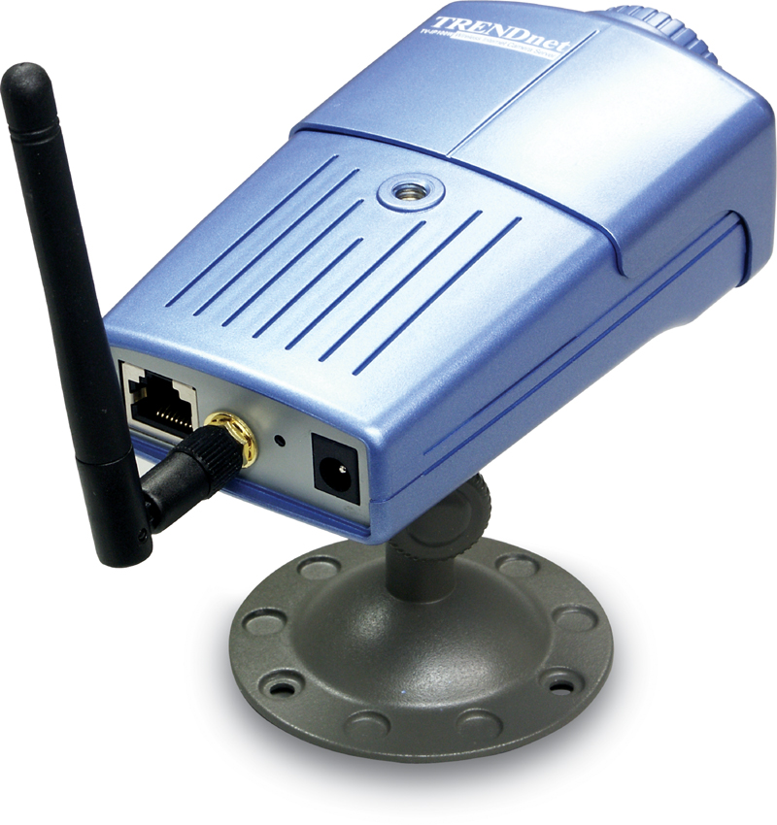
TOP REASONS THE TV-IP100W IS A LASTING TREND

Integration Friendly: Connects to 10/100Mbps, or IEEE 802.11b 11Mbps wireless network
Economical: Built-in web server; does not require additional computer and software
Flexible: Install it in local area network or connect it to Internet for remote monitoring
Performance: Color 640x480 pixels resolution with up to 20fps video frame rate
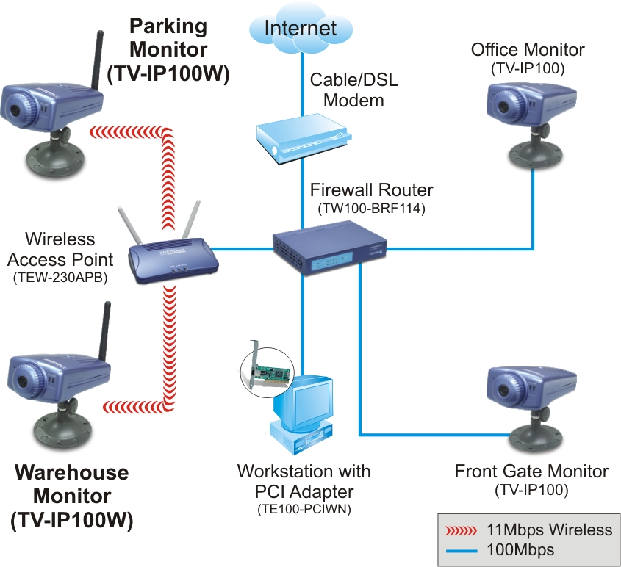

Network Solution for TV-IP100
Product Information

TV-IP100 Basic Internet Camera
TV-IP100W Basic Wireless Internet Camera
TV-IP200W Wireless Internet Camera Server
TV-IP200 Internet Camera Server

To order please call: 888-326-6061
3135 Kashiwa Street • Torrance, CA 90505 • (310) 891-1100 • Fax: (310) 891-1111
Sales: sales@trendware.com • Support: techsupport@trendware.com

