



2-port USB 2.0 CardBus Adapter
The TU2-PCBUS offers two High Speed USB 2.0 ports designed for adding the new USB technology to existing Laptop/Notebook Computers. Computer users can instantly enjoy the latest USB 2.0 devices with 480Mbps transfer speed. The TU2-PCBUS is also backward compatible with existing USB 1.1 devices for extended compatibility. The TU2-PCBUS features CardBus PC Card Type II interface for maximum data transfer throughput between the host PC and the USB devices. Installation is a snap with TU2-PCBUS Plug-n-Play functionality. Additional USB 2.0 ports can be obtained by using the TU2-400, 4-port High Speed USB 2.0 hub, the ideal companion for the TU2-PCBUS.

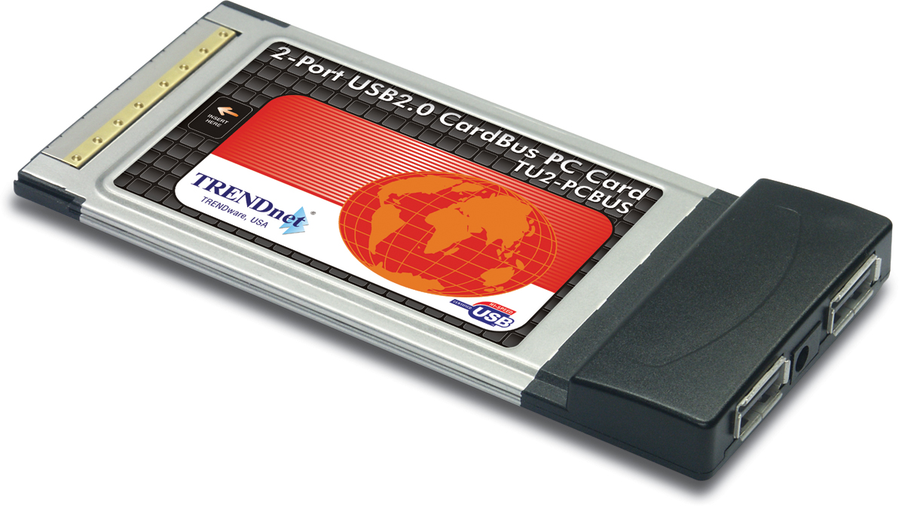

TU2-PCBUS

FEATURES

- 32-bit CardBus PC Card type II interface
- USB 2.0 specifications compliant and backwards compatible with USB 1.1
- Two USB 2.0 Ports
- Allows Simultaneous Operation of USB 1.1 and USB 2.0 Devices
- Supports high-speed (480Mbps), full-speed (12Mbps) and low-speed (1.5Mbps) data transfer modes
- Compatible with Windows 98SE/ME/2000/XP
- Plug-n-Play Installation
- Supports USB Hubs, Removable Drives, Digital Cameras, Scanners, CD-RW/DVD ROMs,
PC Video Cameras, Printers, CF/SM/MMC/SD/Memory Stick Readers/Writers and more.
- 3-year warranty

TREND SPEC’S

Standard: USB Specification 1.1, and 2.0
Data Speed: High-Speed: 480 Mbps
Full-speed: 12 Mbps
Low-speed: 1.5 Mbps
Host Interface: 2-Port Hi-Speed USB 2.0 with Type-A Connectors.
Support Suspend Power Saving mode
Driver Support: Windows 98SE/ME/2000/XP
Power Consumption: 3.3V DC, 1A max. (165mA @ idle)
Dimensions (WxHxD): 112 x 54 x 11 mm (4.4 x 2.13x 0.43 inches)
Weight: 40 g (1.4 oz.)
Operating Temp.: 5˚ ~ 50˚ C (41˚ ~ 122˚ F)
Storage Temp.: -10˚ ~ 60˚ C (14˚ ~ 140˚F)
Operating Humidity: 20 % ~ 80 % non-condensing
Certifications: FCC, CE

TOP REASONS THE TU2-PCBUS IS A LASTING TREND

Compatibility: TU2-PCBUS is compatible with Windows 98SE/ME/2000/XP.
Flexibility: Supports both USB 2.0 Hi-Speed and USB 1.1 devices.
Installation: Easy installation with Plug-n-Play setup.
Speed: Supports 480Mbps High-Speed, 12Mbps Full-Speed, or 1.5Mbps Low-Speed USB operation mode.

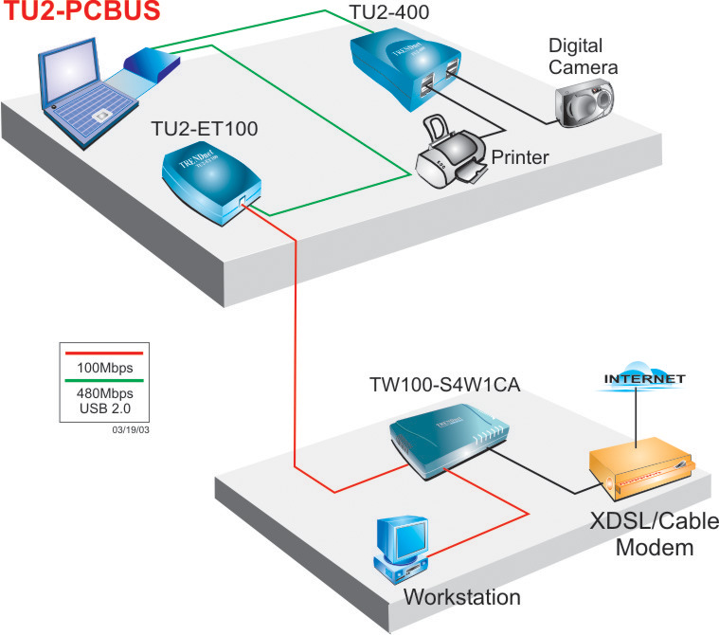

TU2-PCBUS Application

TU2-PCBUS 2-port USB 2.0 CardBus Adapter
Product Information

TU2-400 4-port Hi-Speed USB Hub

To order please call: 888-326-6061
3135 Kashiwa Street • Torrance, CA 90505 • (310) 891-1100 • Fax: (310) 891-1111
Sales: sales@trendware.com • Support: techsupport@trendware.com ss06042003

