


TU-S9
USB to Serial Converter

This USB to Serial converter allows you to connect a RS-232 serial device such as a modem to a USB port on your Desktop or Laptop PC.
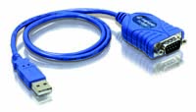

TU-S9 (v1.1R)
Features
- Compliant with USB 1.1 Specifications
- Supports RS-232 Serial Interface
- Supports up to 500kbps Data Transfer Rate
- Detects USB Suspend Condition
- Compliant with Windows 98SE/ME/2000/XP
- Install as a standard Windows COM port, Full RS-232 modem control signals, RS-232 data signals; TxD, RxD, RTS, CTS, DSR, DTR, DCD, RI, GND
- Supports BUS Power, no External Power Adapter Required
- Supports Plug & Play and Easy Installation
- 2-Year Warranty

Specifications Solution for TU-S9
Hardware
Interface | USB 1.1 Type A  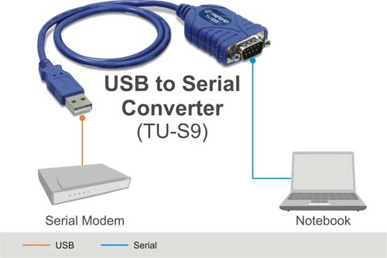  RS-232 (9-pin) Male
Supported OS | Windows 98SE/ME/2000/XP
Cable Length | 6.9 cm (27 inches)
Cable Gauge | 28/24 AWG
Data Rate | 500kbps
Power Consumption | 500mA (max)
Weight | 75g. (0.2 lb)
Operating Temperature | 0° ~ 40° C (32° ~ 104° F)
Storage Temperature | -10° ~ 45° C (14° ~ 113° F)
Humidity | 85%  (Non-Condensing)
Certification | FCC, CE
Package Contents System Requirement
- TU-S9 - PC with Supported Operating Systems
- Quick Installation Guide - 64MB RAM or above
- Driver CD-ROM - 1 x USB 1.1 Compliant Port

