


8-Port 10/100Mbps PoE Fast Ethernet Switch

TPE-S44 8-Port Smart Switch integrates Power over Ethernet (PoE) and network management features into a cost effective and scalable solution. The TPE-S44 reduces equipment cost by delivering data and power over existing network cable infrastructure.
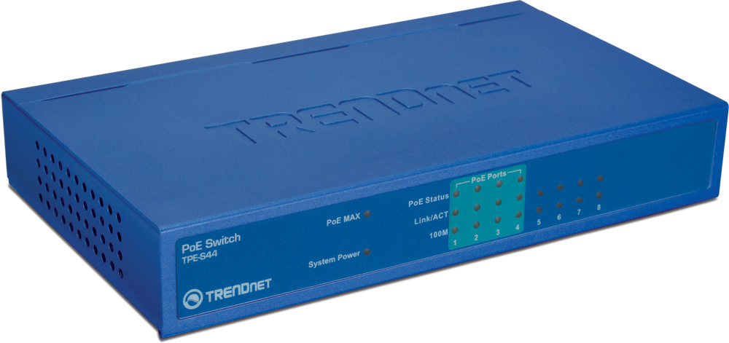

TPE-S44 (A1.0R)
Features
- IEEE 802.3af Power over Ethernet (PoE) Standard Compliant
- 8 x 10/100Mbps Auto-Negotiation and Auto-MDIX Fast Ethernet RJ45 Ports
- Built-in 4 PoE Ports (Port 1 ~ Port 4)
- Supports PoE Power Maximum 15.4 watts for each POE port
- Supports PoE Powered Device(PD) classification identify
- Full Wire-Speed Non-Blocking Reception and Transmission
- Store and Forward Switching Method
- 96Kbytes RAM Data Buffer and 1K entries MAC Address Table
- Extensive Diagnostic LED’s on the Front Panel
- IEEE 802.3x Flow Control for Full-Duplex Mode; Back Pressure Flow Control for Half-Duplex Mode
- 5-Year Warranty
Specifications
Hardware
Standard | IEEE 802.3 10Base-T  IEEE802.3u 100Base-TX  IEEE 802.3af Power over Ethernet
Network Media | 10Mbps: Cat 3,4,5 Unshielded Cable  100Mbps: Cat 5, 5E, 6 Unshielded Cable
Protocol / Topology | CSMA/CD ; Star
Ports | 4 x 10/100Mbps Auto-MDIX POE Ports (1~4)  4 x 10/100Mbps Auto-MDIX Fast Ethernet Ports (5 ~8)
Data Transfer Rate | Ethernet: 10/20Mbps (half/full duplex)  Fast Ethernet: 100/200Mbps (half/full duplex)
RAM Buffer / Filtering | 96 Kbytes / 1K entry per device
Power | 48V DC 0.8A External Power Adapter
Diagnostic LEDs | Per Unit: Power, Power MAX  Per Port: Link/Activity, Speed  PoE: PoE Status, Link/Activity, Speed
Power Consumption | 6.3 watts max (no PD Device connected)  36.3 watts max (with 30w PoE Device connected)
Temperature | Operating: 0° ~ 40° C (32° ~ 104°F)  Storage: -10° ~ 70° C (14° ~ 158°F)
Humidity | 10%- 90% (non-condensing)
Dimensions | 171 x 98 x 29mm (6.7 x 3.7 x 1.1in.)
Weight | 430g (13.8oz.)
Certification | FCC, CE
PoE
Power over Ethernet | Up to 15.4 watts per Port; PD classification Identify  PoE Over Current Protection; PoE Circuit Sorting Protection  PoE Power on RJ-45 pin 3,6 for Power+ and pin 1,2 for Power-

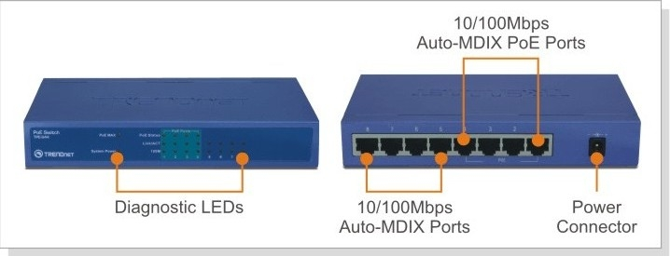

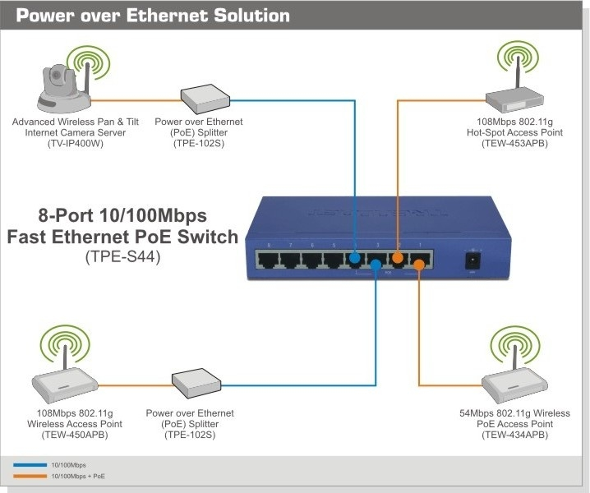

Package Contents Related Product
- TPE-S44 - TPE-101I
- Multi-Language User’s Guide - TPE-102S
- Power Adapter (48V DC, 0.8A) - TPE-S88
- TPE-S224WS

To order please call: 888-326-6061
20675 Manhanttan Place • Torrance, CA 90501 • (310) 961-5500 • Fax: (310) 961-5511

Sales: sales@trendnet.com • Support: techsupport@trendnet.com
Tech Support Hot Line: 1-310-626-6252

Official Site: www.TRENDNET.com

