


2-Port USB Hub and PS/2 KVM Switch

with Audio

TRENDnet's TK-210K 2-port USB and PS/2 KVM Switch with Audio & Microphone kit lets you control 2 USB enabled multimedia PCs with just one keyboard, monitor, mouse, microphone, and a set of speakers. TK-210K not only allows you to share your monitor, keyboard and mouse, but with the build-in 2-port USB hub, you can also share up to two USB devices. With just a simple press of a button, you can select the PC that you would like to operate, eliminating the hassle of cable swapping between 2 PCs. TRENDnet's TK-210K UAM comes with a 2-port USB KVM switch and two sets of cables. With it's Hot-Plug, Auto-Scan, Audible Feedback and Hot-Key operating features, the TK-210K UAM is the perfect choice for managing 2 PCs.

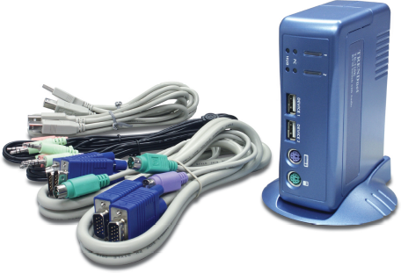

TK-210K

FEATURES
- Use one keyboard, monitor, and mouse to control two computers
- PS/2 and USB Keyboard/Mouse emulations
- 2-Port KVM Switch in compact size design
- Built-in 2-Port USB 1.1 Hub for sharing USB devices
- UHCI, OHCI USB interface support
- Support very High Video Quality, up to 1920 x 1440
- Includes two sets of KVM, USB, and Audio & Microphone cables
- Supports computers with Windows 98/ME/2000/XP, Mac OS, Linux and Netware
- Multi-platform support for PC and Macintosh G3 / G4 / iMac
- Hot-Plug feature; add PCs or remove connected PCs for maintenance without powering down the KVM switch or other PC’s
- No software required, easy PC selection via Push Button or Hot-Keys
- Auto-Scan Mode for monitoring PCs
- LED display for easy status monitoring
- Beeping sound for port switching confirmation
- 2-Year Warranty
TREND SPEC’S
PC Port Connectors: 2 x USB 1.1 Type B port
2 x VGA HDB15 (15-pin) female connector
2 x 3.5mm audio jack
2 x 3.5mm microphone jack
USB Port : 2 x USB 1.1 Type A Port
Console Port Connectors: 1 x PS/2 keyboard 6-pin mini-DIN female
1 x PS/2 mouse 6-pin mini-DIN female
1 x VGA HDB15 (15-pin) female
1 x 3.5mm audio jack
1 x 3.5mm microphone jack
KVM Cable: 2 x 3-in-1 KVM cable (male to male), 1.2 meters (4 feet)
2 x USB A-B cable, 1.2 meters (4 feet)
2 x Audio & Microphone cable, 1.2 meters (4 feet)
VGA Resolution: 1920 x 1440
Port Selection: Push Buttons and Hot-Keys
Auto-Scan Intervals: 10 seconds (non-adjustable)
Power Supply: Powered via PS/2 or USB Interface. Optional 9V DC, 500mA adapter
Dimensions (L x W x H): 137 x 88 x 44 mm (5.39 x 3.46 x 1.73 inches)
Weight: 295 g. (10.5 Oz.)
Temperature: Operating: 0° ~ 40°C (32° ~104° F); Storage: -20° ~ 60°C (-4° ~ 140° F)
Humidity: 0%~90% RH, Non-Condensing
Emissions: FCC, CE



TOP REASONS THE TK-210K IS A LASTING TREND

Integration Friendly: Does not require driver/software for the installation and operation. Switching between PCs with the push button or Hot-Key operation.
Flexible: Hot-Plug feature, add PCs or remove connected PCs without powering off the KVM switch or the other PCs.
Cost Effective: Manage two PCs with single keyboard, monitor, mouse and speakers/microphone; and share USB devices. Save on equipment cost, utility, and space.
Performance: Support very High Video Quality up to 1920 x 1440. Keyboard status is saved for each PC.
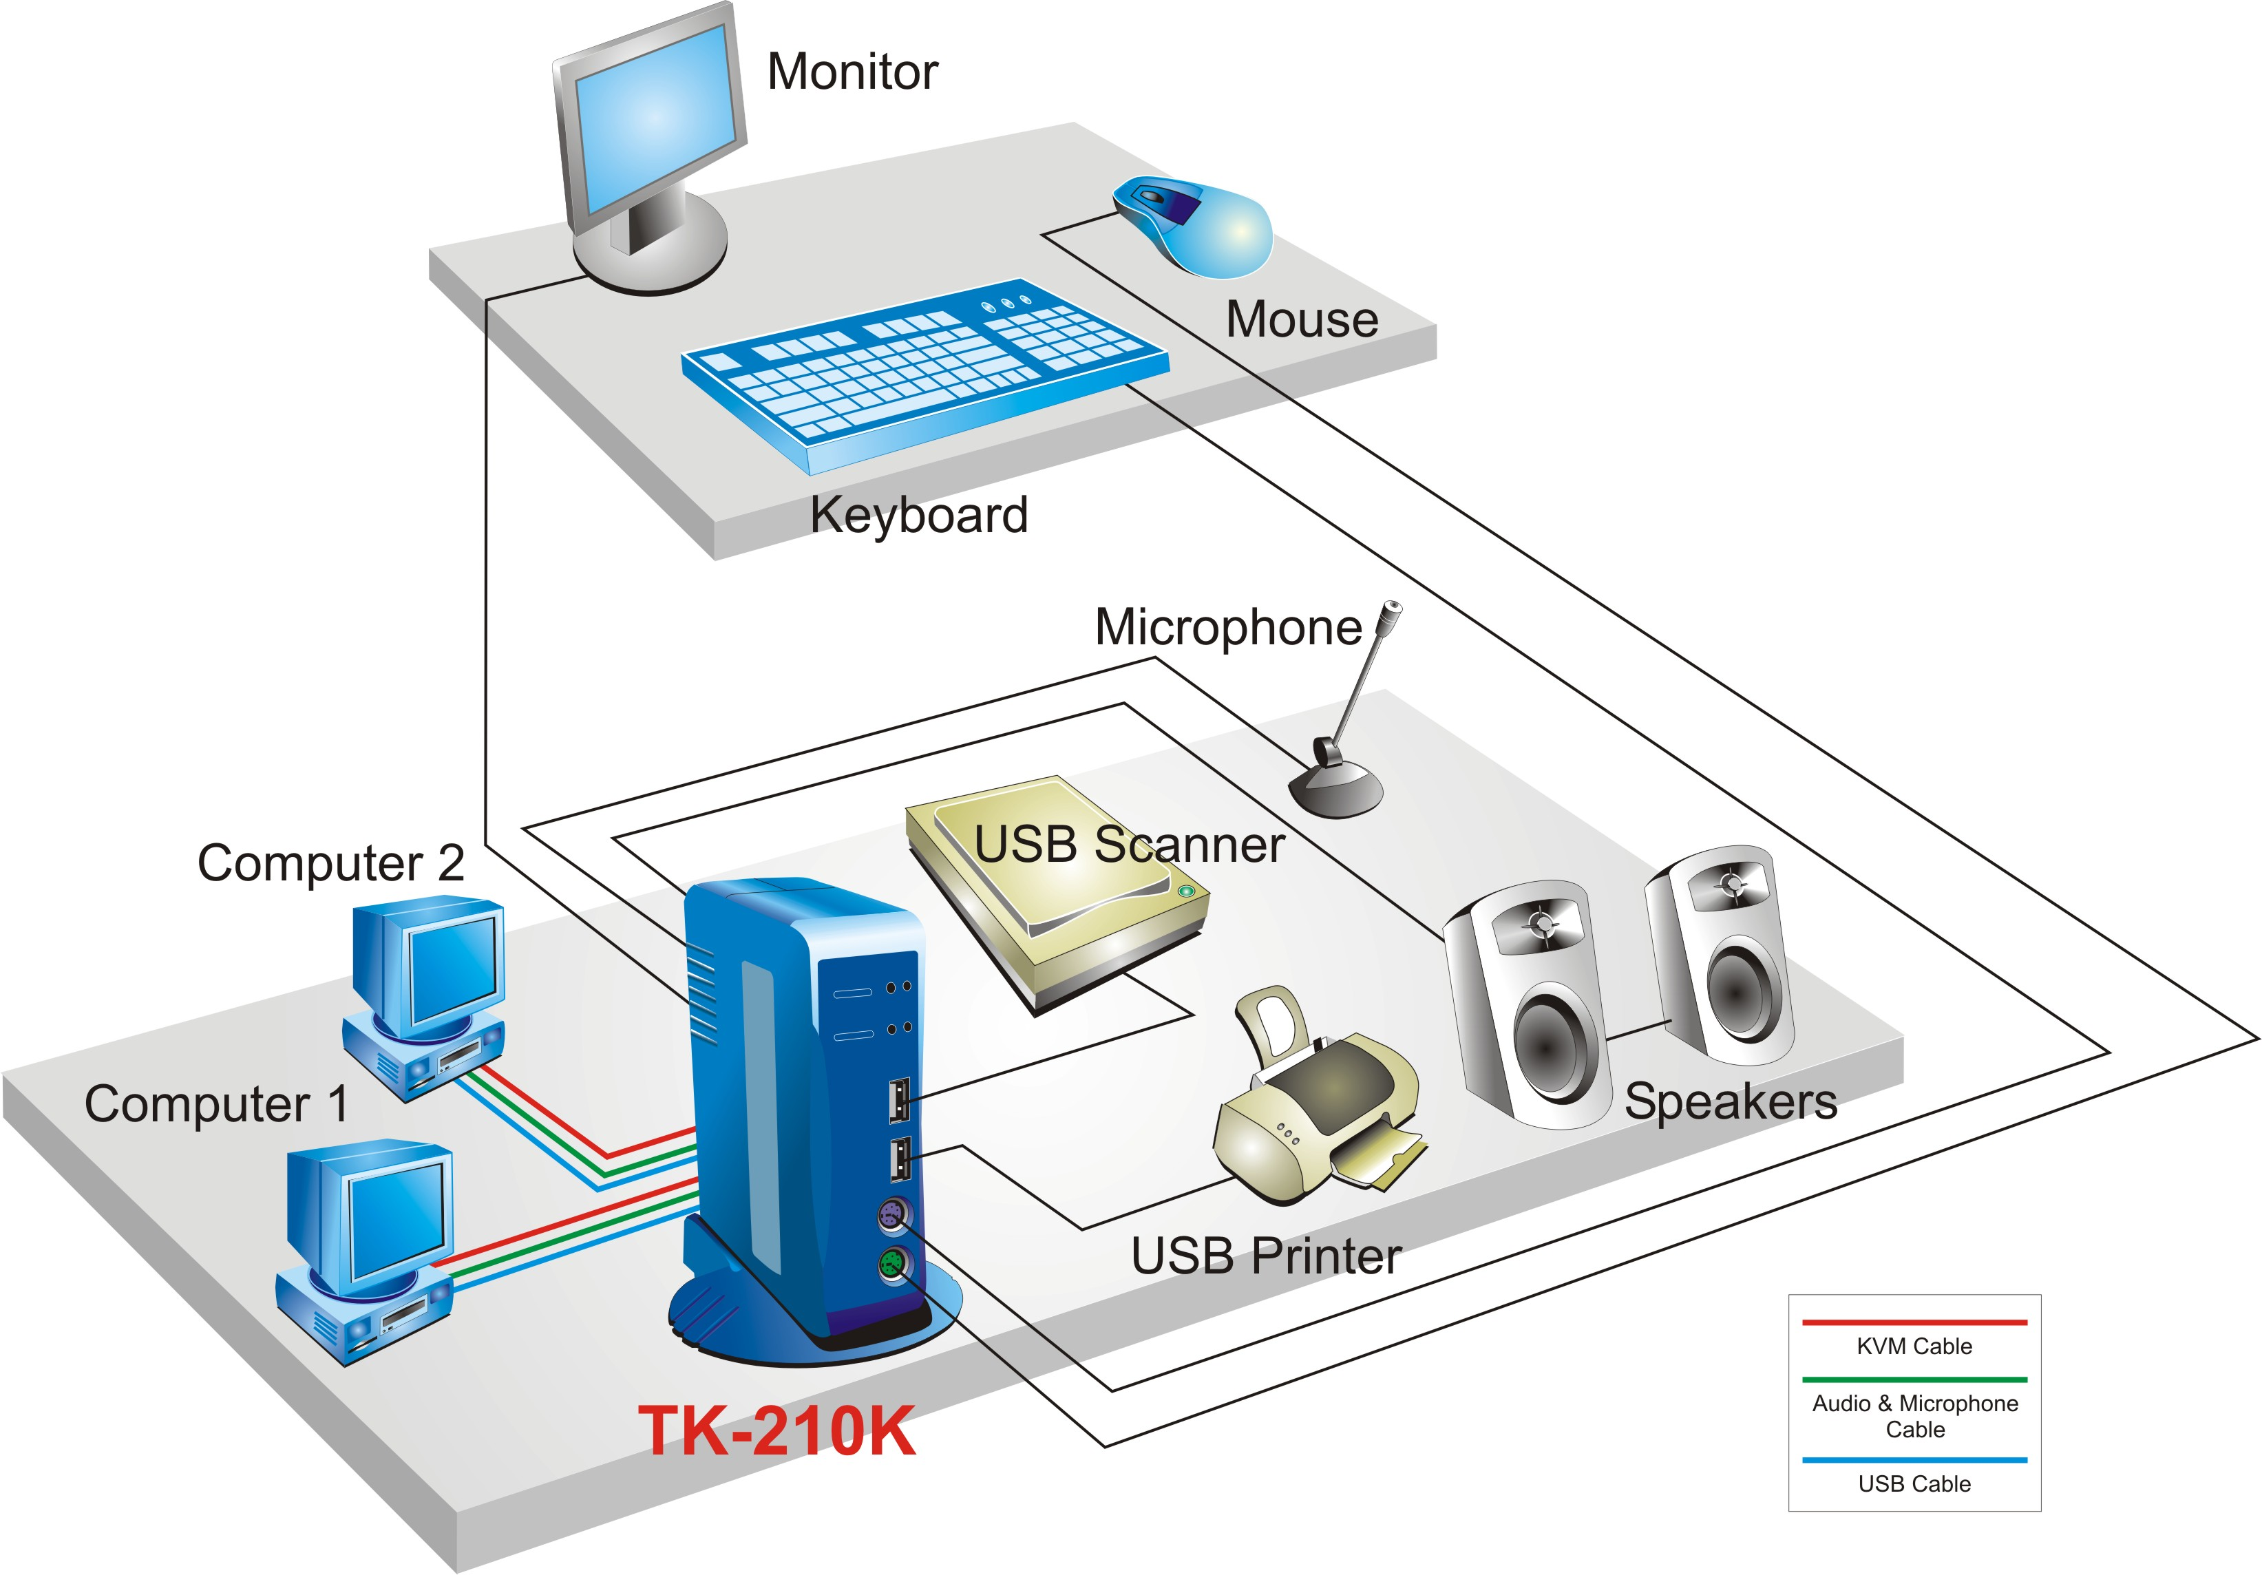

KVM Solution for TK-210K

Product Information

TK-210K 2-Port USB and PS/2 KVM Switch with Audio
TK-205i 2-Port KVM Switch with Integrated KVM Cables
TK-200K 2-Port KVM Switch Kit
TK-400K 4-Port KVM Switch Kit
TK-401R 4-Port Rack Mount KVM Switch
TK-801R 8-Port Rack Mount KVM Switch
TK-802R 8-Port Stackable Rack Mount KVM Switch (with OSD)

To order please call: 888-326-6061
3135 Kashiwa Street • Torrance, CA 90505 • (310) 891-1100 • Fax: (310) 891-1111

Sales: sales@trendware.com • Support: techsupport@trendware.com

