



TFW-H2PC(v1.1R)
2-Port FireWire Host PC Card

This 2-Port FireWire Host PC Card gives your Laptop PC two IEEE 1394 FireWire ports so you can easily connect to digital camcorders, external hard-drives, and other FireWire peripherals.

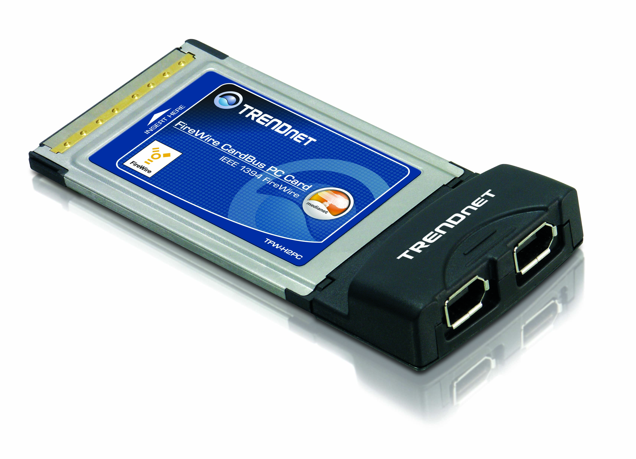

Features
- 2 x IEEE 1394 FireWire Port
- 32-bit CardBus PCMCIA Type II Slot Compatible
- Compliant with IEEE1394A Standard and Backward Compatible with IEEE 1394-1395 Devices
- Provides High Speed Data Transfer Rate up to 400Mbps
- Supports up to 63 FireWire Devices
- Compatible with Windows 98(SE)/ME/2000/XP Operating Systems
- Supports Plug & Play and Easy Installation
- 2-Year Warranty

Specifications Solution for TFW-H2PC
Hardware

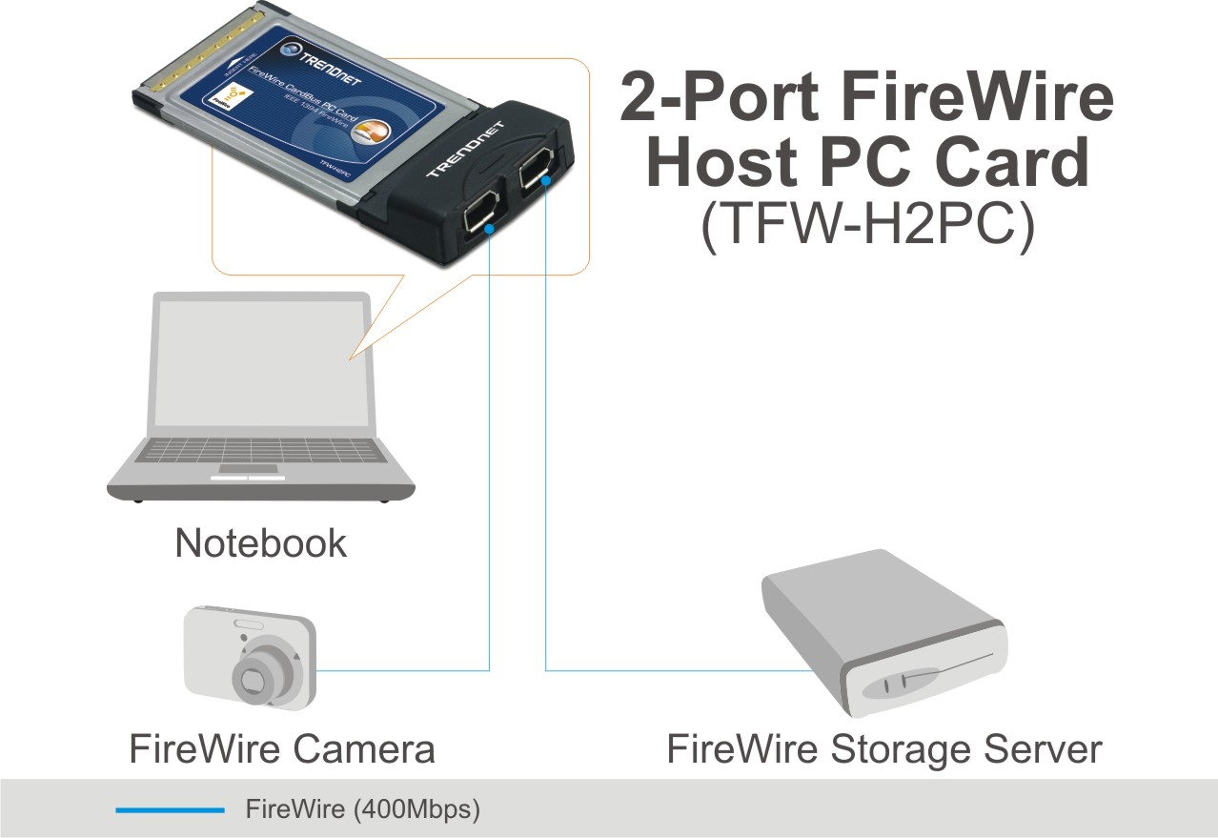
Interface | 32-bit CardBus PCMCIA Type II
Standards | IEEE 1394A, 1394-1395
Ports (6-pin) | 2 x IEEE 1394 FireWire Port
OS Compliant | Windows 98(SE)/ME/2000/XP
Data Rate | 100/200/400Mbps
Power Consumption | 500mA (max) per port
Dimensions (LxWxD) | 120 x 53 x 15mm  (4.7 x 2.1 x 0.6 inches)
Weight | 40g (1.4oz)
Operating Temperature | 0° ~ 40° C (32° ~ 104° F)
Storage Temperature | -10° ~ 45° C (14° ~ 113° F)
Humidity | 0 %~ 85% (Non-Condensing)
Certification | FCC, CE
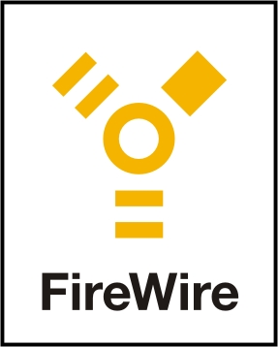
Package Contents System Requirement
- TFW-H2PC - PC with Supported Operating Systems
- Quick Installation Guide - Available PCMCIA Type II slot

