


LMR400 N-Type Male to N-Type Female Cable
The LMR400 N-Type Male to N-Type Female cable extends your wireless Antenna up to 6 or 12 meters to provide optimal placement for your antenna outdoors. Connect business networks from building to building wirelessly or provide wireless Internet access for hot spot applications! This cable makes wireless communication possible by providing low loss communication between your access point and antenna.

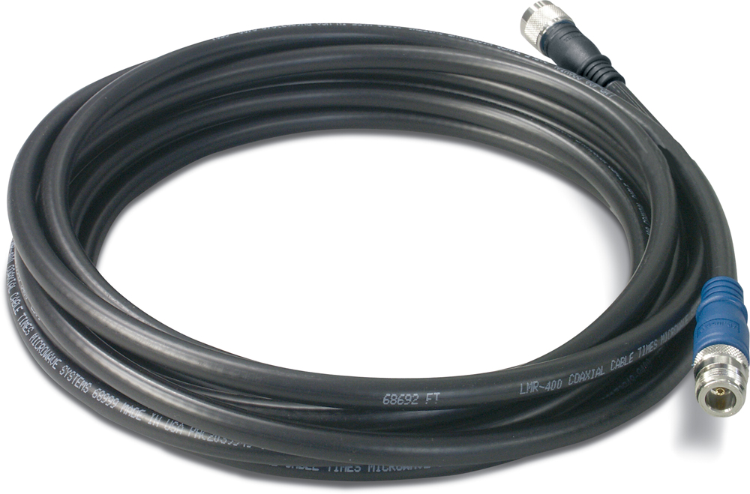

TEW-L406/TEW-L412

Features
- Wi-Fi Compliant with 2.4GHz 802.11 b/g & 5GHz 802.11a Devices for extending wireless networks
- N-Type Male to N-Type Female Connector.
- Optimal placement of your existing Wi-Fi Device permits you to maximize its wireless performance
- Flexible outer conductor allows the tightest bend radius available for any cable of similar size and performance
- Provides flexible Low-loss communication for wireless antenna
- 50dB RF Shielding is 10 dB greater than typical single shielded coax (40 dB).
- Multi-ply bonded outer foil conductor is rated conservatively at > 90 dB.
- Weatherproof cable design for outdoors exposure with best materials for UV resistance
- Polyethylene jacketed cable designed for outdoor use
- Easy and quick deployment into a WLAN environment

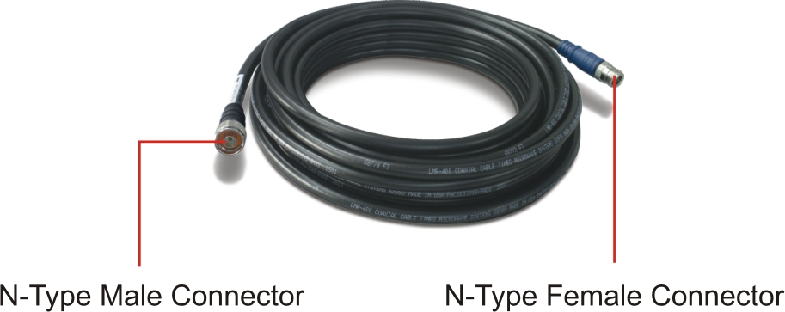

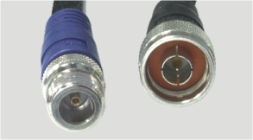

N-Type Male
Connector
N-Type Female
Connector

Interface



Specifications

Construction |  |  | Electrical
Inner Conductor (BCCAI) |  | 0.108 in. (2.74 mm) | Cut-off Frequency | 16.2 GHz
Dielectric (Foam PE) |  | 0.285 in. (7.24 mm) | Velocity of Propagation | 85%
Outer Conductor (Aluminum Tape) |  | 0.291 in. (7.39 mm) | Dielectric Constant | 1.38
Over Braid (Tinned Copper ) |  | 0.320 in. (8.13 mm) | Time Delay | 1.20 nS/ft (3.92 nS/m)
Jacket (PE) |  | 0.405 in. (10.29mm) | Impedance | 50 ohms
Mechanical |  |  | Capacitance | 23.9 pF/ft (78.4 pF/m)
Bend Radius: Installation |  | 1.0 in. (25.4mm) | Inductance | 0.060 uH/ft (0.20 uH/m)
Bend Radius: Repeated |  | 4.0 in. (101.6 mm) | Shielding Effectiveness | > 90 dB
Bending Moment |  | 0.5 ft-lb (0.68 N-m) | DC Resistance  Inner Conductor  Outer Conductor | 1.39 ohms/1000ft  (4.6 ohms/km)  1.65 ohms/1000ft  (5.4 ohms/km)
Weight |  | 0.068 lb/ft (0.10 kg/m) | DC Resistance  Inner Conductor  Outer Conductor
Tensile Strength |  | 160 lb (72.6 kg) | DC Resistance  Inner Conductor  Outer Conductor
Flat Plate Crush |  | 40 lb/in. (0.71 kg/mm) | DC Resistance  Inner Conductor  Outer Conductor
Environment |  |  | DC Resistance  Inner Conductor  Outer Conductor
Temperature | Operating: -40° C ~ 85°C (-40°F~185°F)  Storage: -70° C ~ 85°C (-94°F~185°F) |  | Voltage Withstand | 2500 Volts DC
Temperature |  |  | Jacket Spark | 8000 Volts RMS
Temperature |  |  | Peak Power | 16 kW

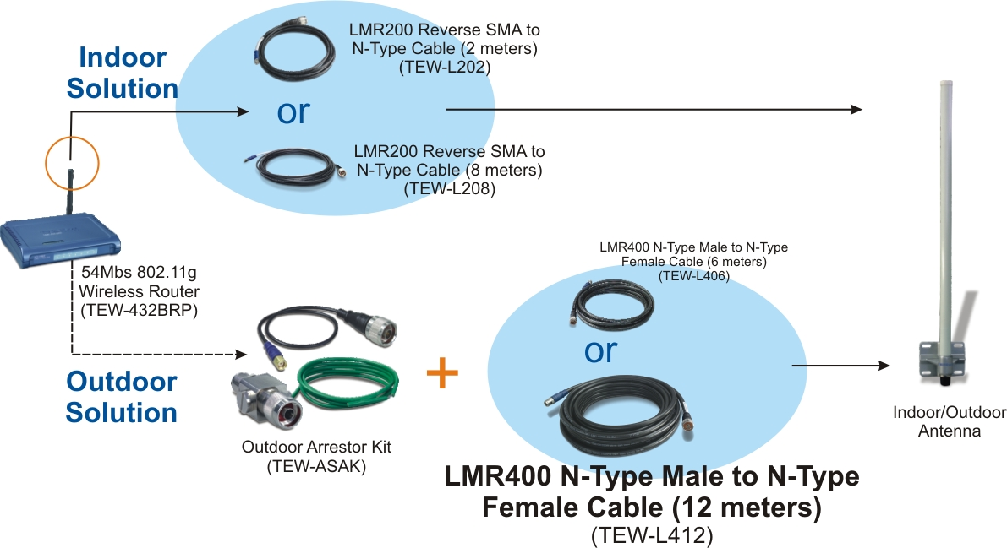
Antenna Cable Solution

Package Contents Related Product
- TEW-L406 / TEW-L408 - TEW-AO08O/TEW-AO10O
- Weatherproof Tape - TEW-ASAK
- User’s Guide - TEW-L202/TEW-L208

To order please call: 888-326-6061 • Sales: sales@trendnet.com
Support: support@trendnet.com • Tech Support Hotline: 1-888-777-1550
Official Site: www.trendnet.com

