


108Mbps 802.11g MIMO Wireless Router
Using the latest technology, the MIMO 802.11g Wireless Router offers a robust wireless solution to extend wireless coverage and improve network performance. It’s also backward compatible with 802.11g and 802.11b, so legacy wireless devices can benefit from MIMO’s extended range. For bandwidth intensive applications, the MIMO wireless router offers intelligent stream handling and automatic traffic prioritization. Security features include a built-in SPI firewall to protect you from hackers, and the latest wireless security (WPA2-PSK) to safeguard wireless transmissions. It also offers 8 types of services for Dynamic DNS. Capable of reaching speeds of up to 108Mbps, the MIMO 802.11g Wireless Router is the perfect solution for homes or small businesses.

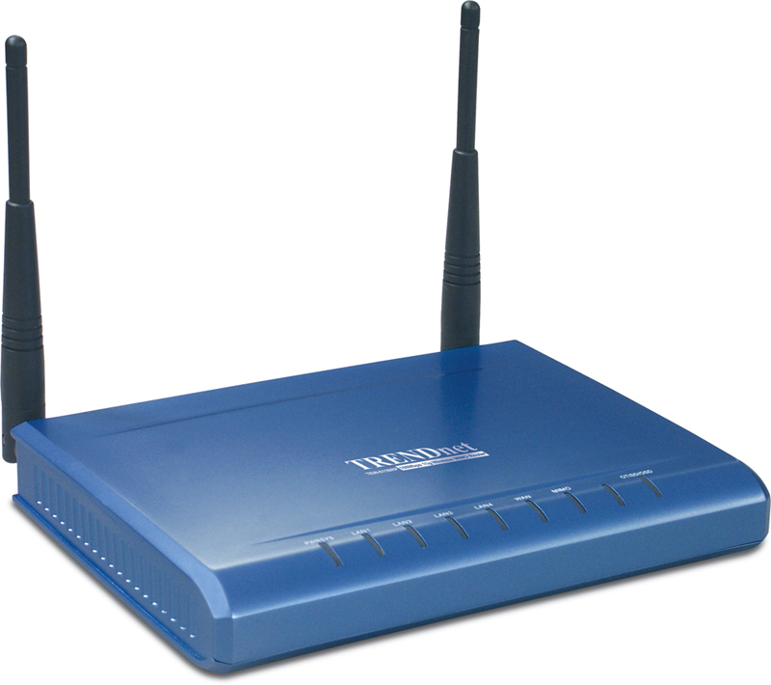

TEW-611BRP

Features
- Wi-Fi Compliant with IEEE 802.11g and IEEE 802.11b Standards
- 4 x 10/100Mbps Auto-MDIX LAN Port and 1 x 10/100Mbps WAN Port (Internet)
- Supports Cable/DSL Modems with Dynamic IP, Static IP, PPPoE, PPTP, L2TP or BigPond Connection Types
- Supports Super G Technology with Data Rate up to 108Mbps (8X Faster) (AP Mode Only)
- Enhance Wireless Coverage up to 800% More Coverage with MIMO Technology
- DHCP Server Feature Allocates up to 252 Client IP Addresses and up to 64 Reservations
- Supports 64/128-bit WEP(Hex), WPA/WPA2 & WPA-PSK/WPA2-PSK Encryptions
- Firewall features Network Address Translation (NAT), and Stateful Packet Inspection (SPI) protects against Dos attacks
- Traffic Control with Virtual Server (max 64 configurable servers) and DMZ
- UPnP (Universal Plug & Play) and ALGs Support for Internet applications such as Email, FTP, Gaming, Remote Desktop,
Net Meeting, Telnet, and more
- Provides Additional Security of Enable/Disable SSID, Internet Access Control (Services, URL and MAC Filtering)
- Supports Static DHCP Client, Static Routing (RIP v1 Announcer) and Dynamic DNS (8 Verified Services)
- Supports Multiple and Concurrent IPSec, L2TP and PPTP VPN Pass-Through Sessions
- Flash Memory for Firmware Upgrade, Save/Restore Settings
- Easy Management via Web Browser (HTTP) and Remote Management
- Compliant with Windows 95/98/NT/2000/XP/2003 Server, Linux and Mac OS
- Coverage up to 150 meters (500ft.) Indoor(depends on the environment)
- Coverage up to 400 meters (1300ft.) Outdoor(depends on the environment)
- 3-Year Warranty
Wireless Networking Solution

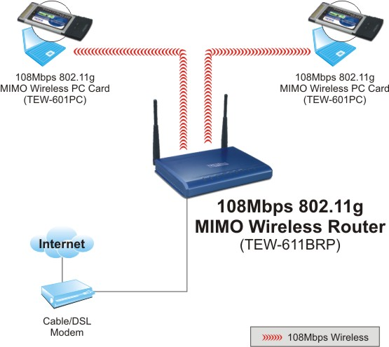
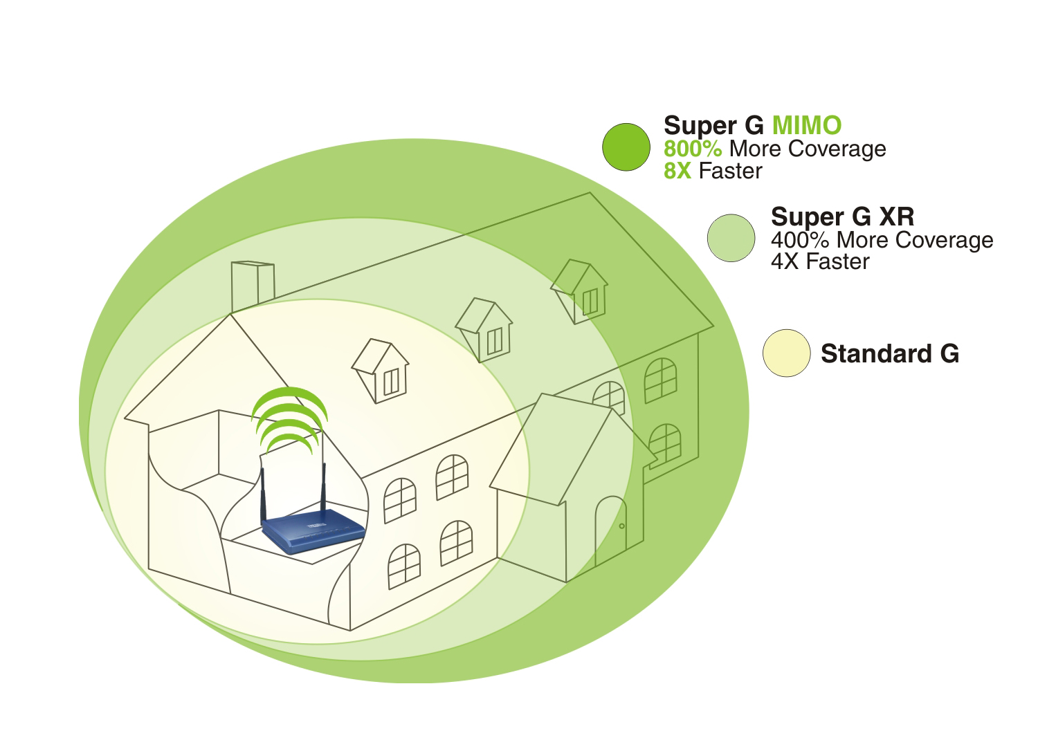

Specification

Hardware
Standards | Wired: IEEE 802.3 (10Base-T), IEEE 802.3u (100Base-TX)  Wireless: IEEE 802.11b (11Mbps), IEEE 802.11g (54Mbps)
WAN | 1 x 10/100Mbps Auto-MDIX Port (Internet)
LAN | 4 x 10/100Mbps Auto-MDIX Port
Slide Switch | Turn On/Off Wireless LAN
Connection Type | Dynamic IP, Static (Fixed) IP, PPPoE, PPTP, L2TP, BigPond
NAT | 4K Configurable NAT entries; Restricted NAPT  Pre-Defined Game Hosting Configurations  Port Triggering for 64 Special Applications  ALG Support – RTP/RTSP, AOL, FTP, ICMP, WMP/MMS, NetMeeting, SIP  ALG Enable/Disable
SPI Firewall | UP to 64 Rules for Rule-Based Firewall  IP Address Ranges, Port Ranges and Schedule  Cyber Attack Protection – Verified Against Over 2000 Attacks
Internet Access Control | Policy Based Parental Controls, Time Based Internet Access, Port Range, Service Filtering, Internet Domain Restriction. URL Filtering, 20 User Defined Schedules, 252 MAC Address Filter Entries
LED Indicator | Power, LAN1~LAN4, WAN, WLAN
Power Adapter | 5V DC, 2A External Power Adapter
Dimension (L x W x H) | 180 x 122 x 30 mm (6.8 x 4.6 x 1.1 inches)
Weight | 320g (0.7 lbs)
Temperature | Operation: 0°~ 40°C (32°F~ 104°F) Storage: -20°~ 60°C (-4°F~140 °F)
Humidity | Max. 90% (Non-Condensing)
Safety & Emissions | FCC & CE

Wireless
Module Technique | 802.11b: CCK (11 and 5.5Mbps), Barker Modulations (1, 2Mbps)  802.11g: OFDM (6, 9, 12, 18, 24, 36, 48, 54Mbps)
Frequency | 2.412 ~ 2.484 GHz
Antenna | 2 x 4dBi (max) Fixed External Dipole Antenna  2 x Internal PCB Antenna
Media Access Protocol | CSMA/CA with ACK
Data Rate | 802.11b: 11Mbps, 5.5Mbps, 2Mbps, and 1Mbps  802.11g: 54Mbps, 48Mbps, 36Mbps, 24Mbps, 18Mbps, 12Mbps, 9Mbps and 6Mbps  Super G: 108Mbps
Security | 64/128-bit WEP (Hex)  802.1X (EAP): WPA/WPA2/802.1x Authenticator  WPA: WPA-PSK, WPA2-PSK  SSID Broadcast Control, MAC Filter (252 entries), IP Filter, URL Filter, Inbound Filter (8 entries)
Output Power | 802.11b: 18dBm (typical)  802.11g: 16dBm (typical)
Receiving Sensitivity | 802.11b: 10 ^{– 5} BER @ -85 dBm  802.11g: 10 ^{– 5} BER @ -74 dBm
Channels | 1~ 11 (US), 1~13 (EU)
Package Contents Related Products
- TEW-611BRP - TEW-601PC
- Multi-Language QIG - TEW-603PI
- CD-ROM (User’s Guide) - TEW-610APB
- Power Adapter (5V DC, 2.5A)
- RJ-45 Cable (1.5m)

To order please call: 888-326-6061
3135 Kashiwa Street • Torrance, CA 90505 • (310) 891-1100 • Fax: (310) 891-1111
Sales: sales@trendware.com • Support: techsupport@trendware.com
www.TRENDnet.com

