


108Mbps 802.11g Wireless Access Point

The TRENDnet TEW-450APB 108Mbps High Speed 802.11g Wireless Access Point with XP support, which achieves “wired” speeds wirelessly with the latest technology. Using frame bursts, frame compression, fast frames and dynamic turbo, the TEW-450APB can have speeds up to 108Mbps. The TEW-450APB is also compatible with standard 802.11b/g and has WPA-PSK, 64/128-bit WEP security.
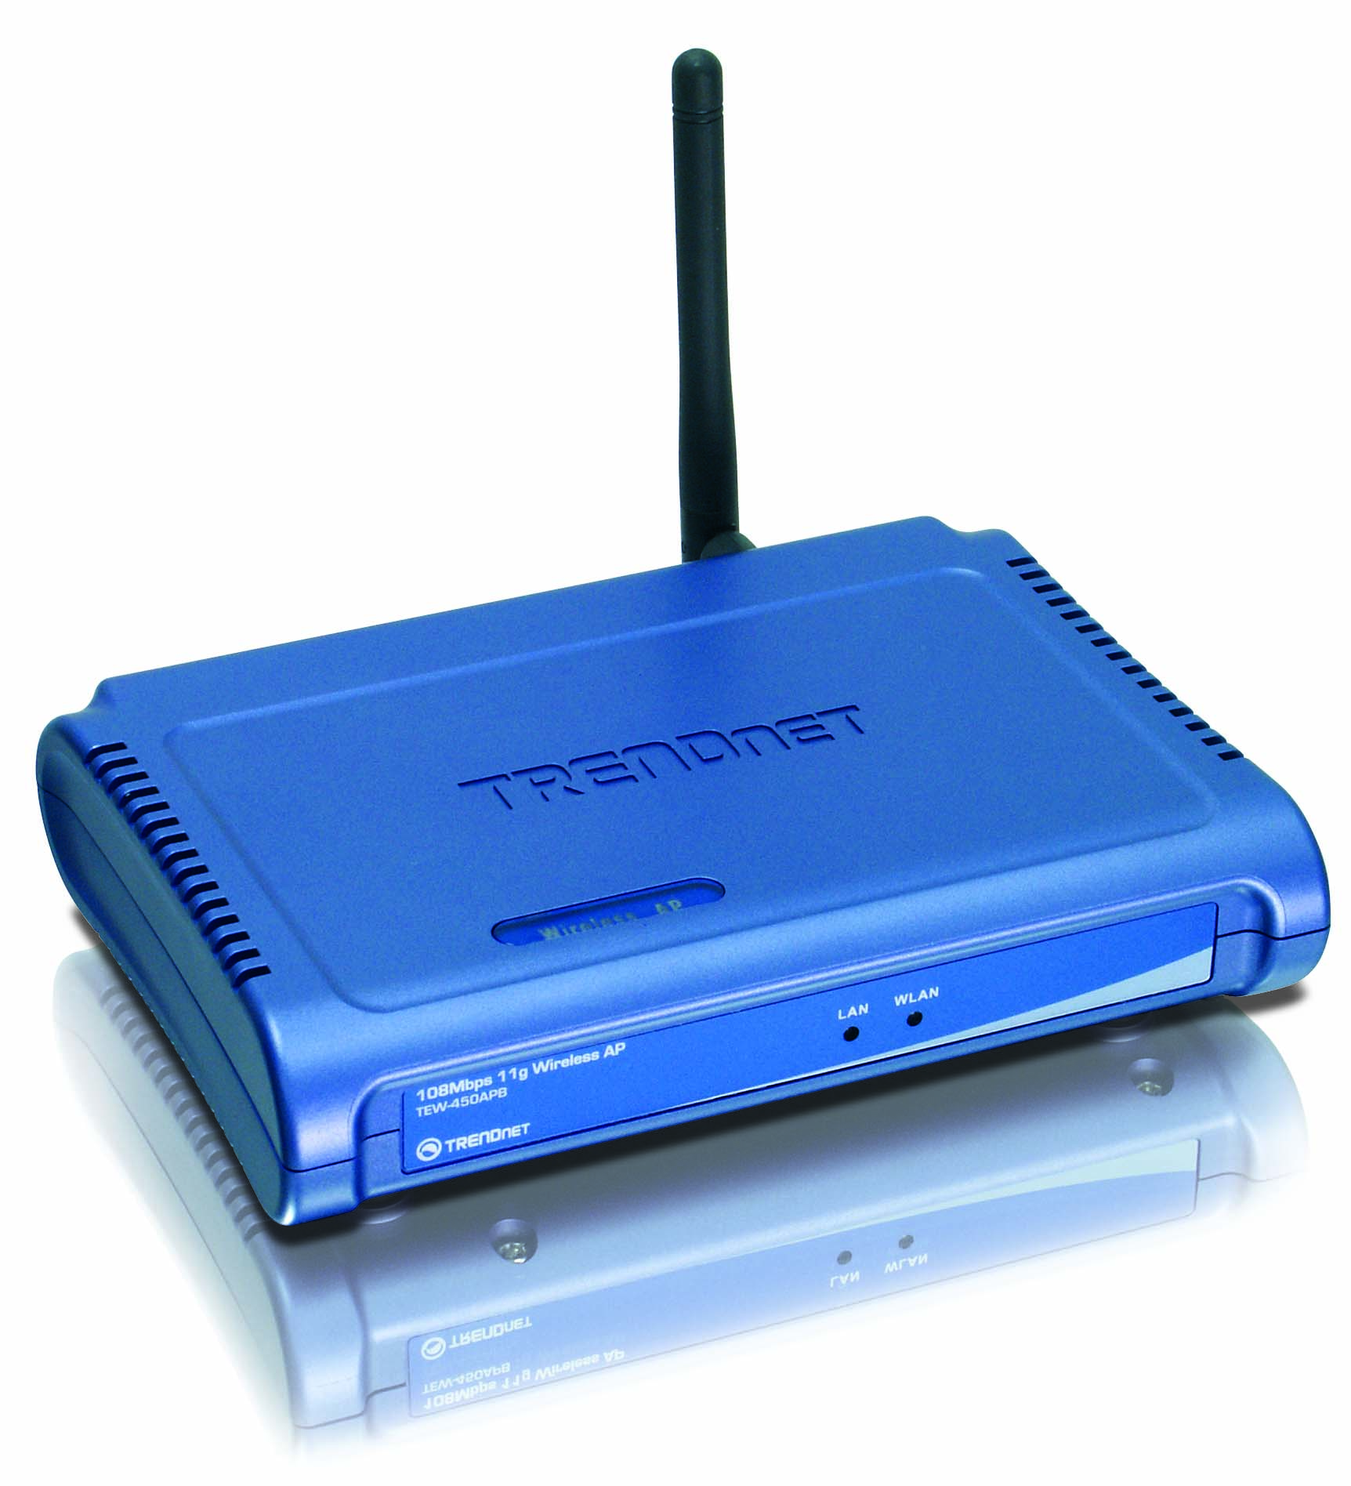

TEW-450APB (B1.0R)
Features
- Wi-Fi Compliant with IEEE 802.11g / 802.11b Wireless Devices
- High-Speed Wireless Access Point with up to 108Mbps Connection
- Supports Access Point, AP Client, Repeater and Bridging (PTP & PTMP) Modes
- Support WDS Enable/Disable Function for AP Client & Repeater Modes
- Supports Super G and XR (eXtended Range) Technology Data Rate up to 108Mbps (AP Mode Only)
- Dynamic Data Rate Scaling at 54, 48, 36, 24, 18, 12, 9 and 6Mbps for 802.11g
- Dynamic Data Rate Scaling at 11, 5.5, 2 and 1Mbps for 802.11b
- Supports ESSID Enable/Disable to Increase Security
- Supports 64/128-bit WEP, WPA-PSK/WPA2-PSK and WPA /WPA2-(EAP-802.1x)
- Allows 802.1x and Non-802.1x Clients Running Simultaneously
- Adjust Transmit Power (Full / Half (-3dB)/ Quarter(-6dB)/ Eighth(-9dB)/ Min)
- Easy Configuration with Web Browser and Built-in Flash Memory for Firmware Upgrade
- Range for Indoor of 30 ~ 50 meters (depends on the environment)
- Range for Outdoor of 50 ~ 200 meters (without XR), 400 ~ 450 meters (with XR) (depends on the environment)
- 3-Year Warranty
Specifications
Hardware
Standards | Wired: IEEE 802.3 (10Base-T), IEEE 802.3/802.3u (100Base-TX) , ANSI/IEEE 802.3 Auto Negotiation  Wireless: IEEE 802.11b (11Mbps), IEEE 802.11g (54Mbps)
LED Indicators | Power, LAN, WLAN
Protocol | TCP/IP
Interface | LAN : 1 x 10/100Mbps Auto-MDIX Port
Antenna | 1 x 2dBi External Detachable Dipole Antenna (Female Reverse SMA Connector)
Network Protocols | 802.3u : 10/100Mbps Fast Ethernet, IP v4, UDP, ICMP, TCP, DHCP
Power Source | 7.5V DC, 1A External Power Adapter
Dimensions (LxWxH) | 150 x 110 x 30 mm (5.9 x 4.3 x 1.2 inches) (without antenna)
Weight | 226g. (8 oz.)
Temperature | Operating: 0°~ 40°C (32°F~ 104°F) Storage: -10°~ 70°C (14°F~ 158°F)
Humidity | Max. 95% (non-condensing)
Certification | FCC, CE
Wireless
Redio Technology | Direct Sequence Spread Spectrum (DSSS)  Orthogonal Frequency Division Multiplexing (OFDM)
Module Technique | 802.11b: CCK, DQPSK, DBPSK  802.11g: OFDM
Frequency Range | 2.4 ~ 2.484 GHz
Transmit Power | 802.11b/g: 15±2dBm (Adjustable)
Data Rate (auto fallback) | 802.11b: 11Mbps, 5.5Mbps, 2Mbps, and 1Mbps  802.11g: 54Mbps, 48Mbps, 36Mbps, 24Mbps, 18Mbps, 12Mbps, 9Mbps and 6Mbps  Super G: 108Mbps
Channels | 1~11 Channel (US) , 1~13 Channel (EU)
Security | 64/128-bit WEP (Hex/ASCII), WPA/WPA2, WPA-PSK/WPA2-PSK  ESSID Control, MAC Address Filter
Management | Windows Based Utility or Web Browser (HTTP)
Receiving Sensitivity | 11Mbps 8% PER @ -85 dBm (typical)  54Mbps 10% PER @ -70 dBm (typical)

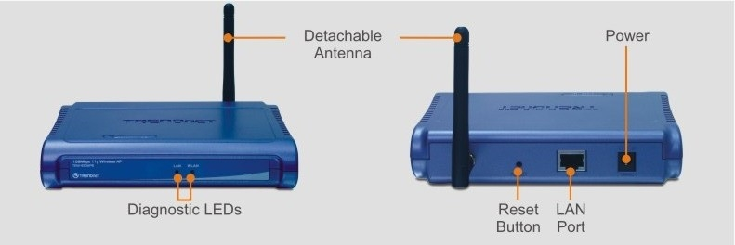
New Implements:

- Chipset Change
- Power Adapter change to 7.5V 1A

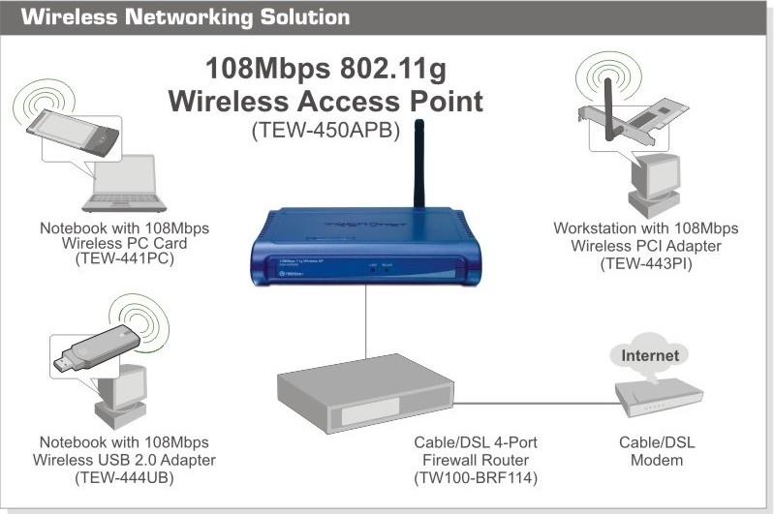

Package Contents Related Products
- TEW-450APB - TEW-441PC
- Multi-Language Quick Installation Guide - TEW-443PI
- CD-ROM (User’s Guide) - TEW-444UB
- Power Adapter (7.5V, 1A) - TEW-452BRP

To order please call: 888-326-6061
20675 Manhanttan Place, CA 90501 • (310) 961-5500 • Fax: (310) 961-5511

Sales: sales@trendnet.com • Support: support@trendnet.com
Tech Support Hot Line: 1-866-845-3673

Official Site: www.TRENDNET.com

