
11/22Mbps Wireless PCMCIA Network Adapter

TRENDnet’s TEW-301PC 11/22Mbps Wireless PCMCIA Network Card is the latest creation for wireless network applications. It complies with IEEE 802.11b and PCMCIA CardBus standards and operates with 2.4GHz Direct Sequence Spread Spectrum (DSSS) transmission technology. With the wireless networking products, users can setup Local Area Network (LAN) without the trouble of installing networking cables. TRENDnet’s TEW-301PC along with TRENDnet’s Wireless Access Point, mobile wireless stations can connect to the wired Ethernet network at home or office to access networked resources – with coverage up to 300 meters.


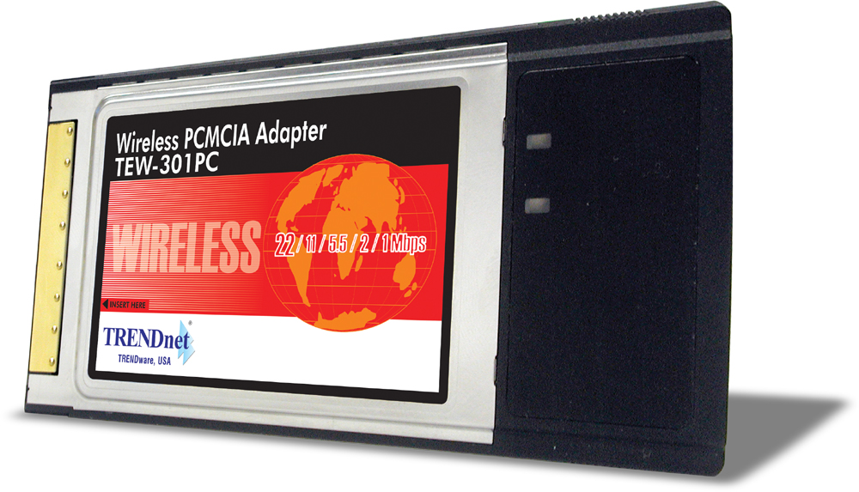

TEW-301PC
FEATURES
- Low interference and high susceptibility guarantee reliable performance
- Provides drivers supporting Windows 98(SE)/ME/2000/XP
- Uses 2.4 GHz frequency band, which complies with worldwide requirement
- Delivers data rate up to 22Mbps
- Dynamically shifts between 22, 11, 5.5, 2 and 1 Mbps network speed (based on signal strength), for maximum availability and reliability of connection
- Supports Ad-Hoc (peer-to-peer) mode and Infrastructure (with Access Point) mode wireless network architecture
- Roaming feature allows users to move between Access Points without loosing their connection
- Ensures great security by providing 64/128/256-bit Wired Equivalent Privacy (WEP) encryption as defined in the IEEE 802.11b standard
- Built-in patch Antenna
- Distance coverage 30 to100 meters indoor, 100 to 300 meters outdoors
- 3-year Warranty
TREND SPEC’S

Adapter Type: 32-bit PCMCIA CardBus
Standards: IEEE 802.11b, Wi-Fi & PCMCIA 2.1 and JEIDA 4.2 Standard
Frequency: 2.4 ~ 2.4835GHz (Industrial Scientific Medical Band)
Channels: 11 Channels (US & Canada)
Data Rate: 22Mbps, 11Mbps, 5.5Mbps, 2Mbps, 1Mbps
Modulation Technology: Direct Sequence Spread Spectrum (DSSS), PBCC (Packet Binary Convolutional Coding), 11-chip Barker Sequence
Antenna: 2dBi Internal Patch Antenna
Media Access Protocol: CSMA/CA with ACK
LED Indicator: Power, Link/Activity
Output Power: 16 ~ 18dBm (typical)
Receiving Sensitivity: -80dBm (typical)
Power Consumption: DC +3.3V/+5V. TX: 650mA max. RX: 350mA
Standby Mode: 350mA (RX); Sleep Mode: 0mA
Dimensions: 128 x 54 x 9.6mm (5.04 x 2.13 x 0.38 inch)
Weight: 40 g. (1.4 oz.)
Operating Temperature: 0° ~ 50° C (32° ~ 122° F)
Storage Temperature: -20° ~ 70° C (-4° ~ 158° F)
Humidity: Max. 95% (Non-condensing)
Certification: CE, FCC

TOP REASONS THE TEW-301PC IS A LASTING TREND

Integration Friendly: Drivers support Windows 98/ME/2000/XP.
Economical: Save time, labor, and material for network cable installation.
Flexible: Creates wireless peer-to-peer network in Ad-Hoc mode or connects to Ethernet LAN in Infrastructure mode using wireless Access Point.
Security: Supports 256-bit Wired Equivalent Privacy (WEP) encryption.
Performance: Connects at a speed up to 22Mbps, which is two times faster than regular 802.11b products.

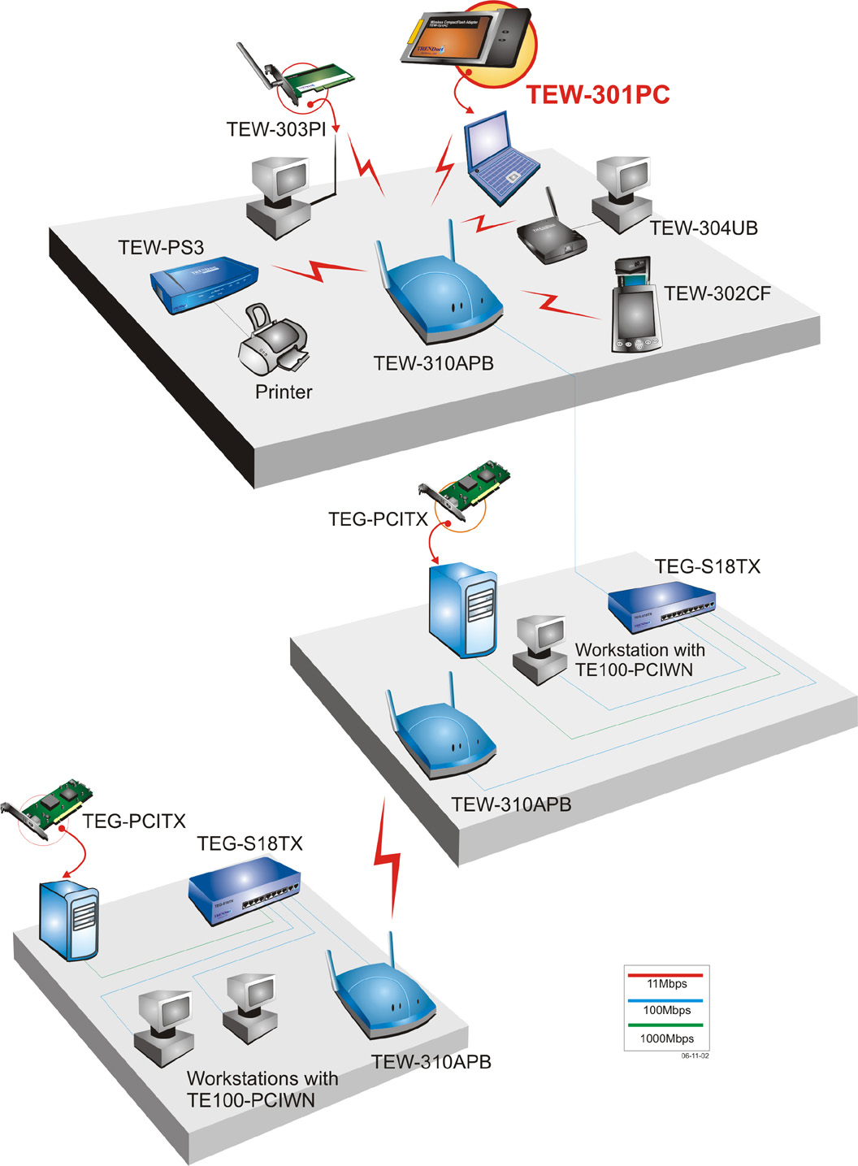

11/22Mbps Wireless Network Solution

TEW-301PC 11/22Mbps Wireless PCMCIA Network Adapter
Product Information

TEW-302CF 11/22Mbps Wireless CompactFlash Network Adapter
TEW-303PI 11/22Mbps Wireless PCI Network Adapter
TEW-304UB 11/22Mbps Wireless USB Network Adapter
TEW-310APB 11/22Mbps Wireless Access Point + Bridge
TEW-311BRP 11/22Mbps Wireless AP Router with 4-Port Switch
TEW-PS3 3-parallel port Wireless Ethernet Print Server


To order please call: 888-326-6061
3135 Kashiwa Street • Torrance, CA 90505 • (310) 891-1100 • Fax: (310) 891-1111

Sales: sales@trendware.com • Support: techsupport@trendware.com

