


16-Port 10/100Mbps Fast Ethernet Switch

TRENDnet’s TE100-S16 is auto-sensing switch that automatically negotiates between 10Base-T and 100Base-TX network speeds. All ports support half- and full-duplex that allows maximum network performance. It is designed to eliminate unnecessary traffic and relieve congestion on critical network paths. Designed and built to increase network bandwidth, TE100-S16 is the best solution for both corporate and small business network environments.

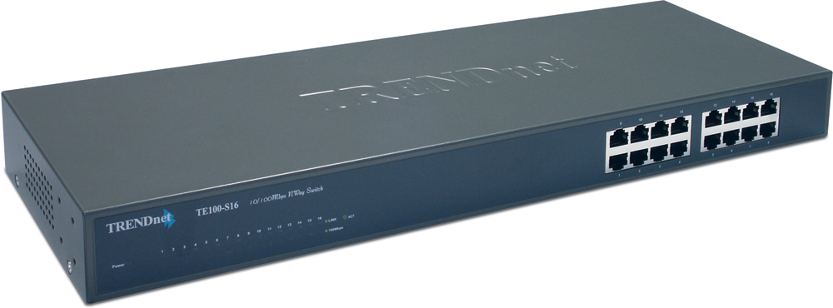

TE100-S16

Features
- Compliant with IEEE 802.3 10Base-T, IEEE 802.3µ 100Base-TX
- 16 x 10/100Mbps Auto-Negotiation and Auto-MDIX Fast Ethernet Ports
- Supports Store and Forward Switching architecture with non-blocking full wire-speed performance
- Full/Half Duplex Transfer Mode for Each Port
- Wire-Speed Filtering/Forwarding Rates
- IEEE 802.3x Flow Control for Full-Duplex Mode
- Backpressure Flow Control for Half-Duplex Mode
- Integrate Address Look-Up Engine, Supports up to 8K Absolute MAC Address
- 512KB per Device RAM Buffer.
- Extensive Front-Panel Diagnostic LEDs
- Plug and Play Design
- Standard 19” (1U) Rack Mount Size (kit included)
- 5-Years Warranty
Specifications
Hardware
Standard | IEEE 802.3 10Base-T  IEEE 802.3u 100Base-TX  ANSI/IEEE 802.3 Auto-Negotiation
Connectors | 16 x 10/100Mbps Auto-MDIX RJ45 Ports
Cabling | Cat. 3,4,5 UTP/STP for 10Base-T  Cat. 5 UTP/STP for 100Base-TX
Supported Cable Length | 100 Meters max.
Protocols | CSMA/CD
Data Transfer Rate | 10Mbps: 10/20Mbps (Half/Full Duplex)  100Mbps: 100/200Mbps (Half/Full Duplex)
Data RAM Buffer | 512KB per device
Filtering Address Table | 8K Entries Per Device
Diagnostic LED | Power, Link/Activity, 100Mbps
Weight | 2.0 kg (4.4 lb)
Dimensions (W x H x D) | 440 x 140 x 44mm ( 17.3” x 5.51” x 1.73”)
Temperature | Operating: 0°C ~ 40°C (32°F ~ 104°F)  Storage: -10°C to 70°C (14°F to 158°F)
Humidity | Operating: 10 % ~ 90 % (non-condensing)  Storage: 5 % ~ 90 %(non-condensing)
Certifications | FCC, CE, VCCI

TOP REASONS THE TE100-S16 IS A LASTING TREND

Integration Friendly | Easily upgrade to Fast Ethernet without changing switch
Economical | Provides 10/100Mbps of Fast Ethernet in the same unit
Flexible | All Ports automatically negotiate 10/100 network speed, half/full modes, and Auto-MDIX connector type
Performance | Supports store and forward switching architecture with non-blocking full wire-speed performance

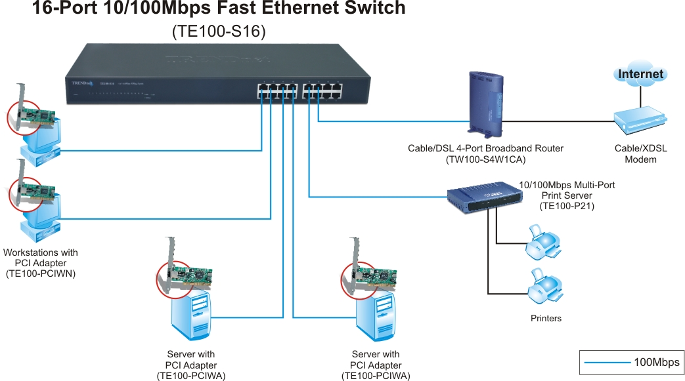

Network Solution for TE100-S16

Package Contents Related Product
- TE100-S16 - TE100-S16E+
- Multi-Language UG - TE100-S24
- Power Cord - TE100-S32+
- Rack Mount Kit

To order please call: 888-326-6061
3135 Kashiwa Street • Torrance, CA 90505 • (310) 891-1100 • Fax: (310) 891-1111

Sales: sales@trendware.com • Support: techsupport@trendware.com
Tech Support Hot Line: (310)626-6252

Official Site: www.TRENDNET.com

