Model: 15-AH25B (H/W: A1)

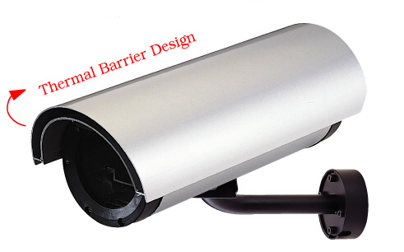
Camera Housing
15-AH25B

Features

- Aluminum construction
- External use
- Flip open top
- 1 Year Warranty

Specification

ITEMS |  | 15-AH25B (H/W: A1)
Housing Size | L / PEAK  D / PEAK  L mm  D mm | 440
Housing Size | L / PEAK  D / PEAK  L mm  D mm | 128
Housing Size | L / PEAK  D / PEAK  L mm  D mm | 384
Housing Size | L / PEAK  D / PEAK  L mm  D mm | 110
Max Camera Size | L mm  W mm  H mm | 220
Max Camera Size | L mm  W mm  H mm | 70
Max Camera Size | L mm  W mm  H mm | 65
Weight |  | 1.85kg
Clear Window Area |  | Ψ78
Glass |  | 2mm
Housing Material |  | Aluminum
Finish |  | Light Gray Powder – coating Body, Black End Caps
Proposal |  | Outdoor
Heater |  | x
Fan |  | x
Power Supply |  | x

Camera Housing
15-AH25B

Supported Models

- TV-IP100 / TV-IP100W
- TV-IP201 / TV-IP201W
- TV-IP301 / TV-IP301W

Ps. Cameras need to use the Camera’s own power adapter

Heavy Duty Bracket
- Cable for camera can be run through centre of bracket for anti tamper protection
- Max Load: 10 kg.
- Construction: Steel
- Height: 230 mm
- Fixing: 4 screws
- Swivel Angle: 90ﾟ
- Tilt Angle: 120ﾟ
- Weight: 4.7kg (10.5lb)
- Dimension: 6.7 x 3 x 48 cm (2.6 x 1.2 x 19 inches)

